AI Based Decision support system for day-ahead electricity prices in the German Power Market

Project Report

Table of Contents
Abstract 6
1. Project Framing 7
1.1 Background 7
1.2 Rationale 7
1.3 Aim 7
1.4 Objectives 8
1.5 Research Questions 8
1.6 Scope 8
2. Fact Finding and Literature Context 9
2.1 The day ahead electricity market 9
2.2 Why day ahead prices are difficult to forecast 9
2.3 Forecasting approaches in the literature 10
2.4 Forecast evaluation and economic relevance 11
2.5 Research gap and project contribution 11
2.6 Section Summary 11
3. Project Requirements 12
3.1 Functional 12
3.2 Non-functional 12
3.3 Data-management 12
4. Project Development and Methodology 13
4.1 Development approach 13
4.2 Summarised Technical Workflow 13
4.3 Technical Environment 13
4.4 Data acquisition 14
4.5 Data pre processing 16
4.6 Feature engineering 17
4.7 Data merging 17
5. Exploratory Data Analysis 18
5.1 Day ahead Price Dynamics 18
5.2 Price Distribution and Extreme Values 19
5.3 Temporal Price Patterns 20
5.4 Relationship Between Load and Prices 22
5.5 Renewable Share and Price Behaviour 23
5.6 Feature Association Analysis 23
5.7 Price Volatility 25
5.8 Summary of EDA Findings 26
6. Forecasting Model Development and Evaluation 27
6.1 Modelling Dataset and Leakage Safe Feature Preparation 27
6.2 Evaluated Models 27
6.3 Evaluation Metrics 28
6.4 Performance Results of Models 28
6.5 Actual vs Predicted Price Behaviour 29
6.6 Forecasting Error Analysis 31
6.7 Feature Importance Analysis 32
6.8 Interpretation in Relation to the Research Questions 33
6.9 Summary of Modelling Findings 34
7. Decision support and Economic Evaluation 35
7.1 Decision support Logic 35
7.2 Scenario Assumptions 35
7.3 Frequency of Recommendation 36
7.4 High-Price Detection Performance 37
7.5 Directional Accuracy 38
7.6 Economic Evaluation 39
7.7 Cumulative Savings Over Time 40
7.8 Example of Decision Recommendations 42
7.9 Interpretation of Practical Value 42
7.10 Limitations 43
7.11 Summary 43
8. Critical Evaluation 44
8.1 Strengths 44
8.2 Limitations 44
8.3 Ethical, sustainability and social considerations 44
8.4 Reflection on development process 44
9. Conclusion and Future Work 45
Appendix A: References 46
Appendix B: Source Code 47
Notebook#1: Data_Acquisition 47
Notebook#2: Data_Cleaning 48
Notebook#3: Feature_Engineering 51
Notebook#4: Data Merging 53
Notebook#5: EDA 54
Notebook#6: Modelling 59
Notebook#7: Decision Support Layer 74

Table of Figures
Figure 1: Summarized Technical Workflow 12
Figure 2: Daily average German day ahead electricity prices and 30-day rolling trend 15
Figure 3: Distribution of hourly day ahead prices before and after inverse hyperbolic sine transformation 16
Figure 4: Average German day ahead price by delivery hour and day of week 17
Figure 5: Monthly average day ahead prices by year 18
Figure 6: Relationship between system load and day ahead electricity prices 18
Figure 7: Relationship between renewable share and day ahead electricity prices 19
Figure 8: Feature association with day ahead electricity prices 20
Figure 9: Focused correlation heatmap for key market variables 21
Figure 10: Rolling volatility of German day ahead electricity prices 22
Figure 11: Model comparison based on MAE: 26
Figure 12: Actual vs predicted day ahead prices for January 2024 26
Figure 13: Distribution of XGBoost forecast errors 27
Figure 14: XGBoost forecast errors over the test period 28
Figure 15: Top XGBoost feature importances 29
Figure 16: Permutation importance for XGBoost 30
Figure 17: Frequency of XGBoost decision recommendations 33
Figure 18: High-price detection performance 34
Figure 19: XGBoost high-price detection confusion matrix 35
Figure 20: Directional accuracy relative to previous-day price 36
Figure 21: Total cost savings compared with fixed-load baseline 37
Figure 22: Cumulative cost savings over the test period 38
Figure 23: Distribution of daily cost savings 39
Figure 24: XGBoost decision recommendations on actual prices 39

Tables
Table 1:L Research Questions 8
Table 2: Model comparison on the 2024 test set 26
Table 3: High-price detection performance 35
Table 4: Directional accuracy relative to previous-day price 37
Table 5: Economic evaluation summary 38

Abstract

This project is to develop an AI based decision support artefact for day ahead/short term electricity prices in the German_Luxembourg electricity market. It is to be noted here that this project is not limited to forecasting the day ahead prices, but to take a step further and build a scenario based decision support system for the electricity market.
To complete this project historical data of electricity prices for years the years 2022, 2023 and 2024 were acquired from the ENTSO-E Transparency Platform using Python in Jupyter Notebook. The final hourly dataframe contains day ahead prices, actual load, solar generation, wind generation and engineered features such as temporal, lag and rolling-window features. In the modelling stage, we compare benchmark methods with ensemble machine learning models, including Random Forest and XGBoost. XGBoost turned out to be the best performing model. It achieved a mean absolute error(MAE) of 7.49 EUR/MWh and an R² value of 0.922 on the test data(year 2024). It substantially outperformed the naive same hour previous day baseline model.
In the final artefact a transparent decision support layer can be found which classifies each hour as one of the following three recommendations, Reduce/Avoid, Shift/Buy or Hold/Normal. A flexible load based economic evaluation shows that the XGBoost strategy reduced the baseline procurement cost by 24,854.69 EUR, which is equivalent to 3.61% over the 2024 testing period. Moving towards the end of the project Streamlit dashboard is also developed to present forecasts, model performance, decision recommendations, feature importance and savings. According to the results the machine learning forecasts support practical and interpretable day ahead electricity price decision making when evaluated beyond accuracy metrics alone.

1. Project Framing

1.1 Background

Due to liberalisation of electricity markets in general has increased the importance of accurate short term price forecasts. In a day ahead market, participants submit bids for electricity delivery for each hour of the following day. Therefore, forecasts support operational planning, procurement and bidding decisions which directly explains the importance of decision making system which can provide better economic value. (Conejo et al. 2005) explains that producers, retailers and large consumers require day ahead price estimates to self-schedule and bid efficiently. (Weron,2014) in their paper similarly argue that price forecasts are a fundamental input to the decision-making mechanisms of energy companies.

1.2 Rationale
Electricity markets are different from ordinary financial assets and commodities. Demand and supply must be balanced at all times in order to avoid grid related issues. Demand follows recurring consumer patterns, and generation/supply has variation due to high renewable energy penetration which in turn is because of unpredictable fluctuations in the weather conditions. These characteristics produce daily and weekly seasonal trends, abrupt spikes and changing volatility (Conejo et al., 2005; Weron, 2014). According to recent research, the expansion of renewables increases the need for flexible models and meaningful exogenous variables such as load, wind and solar conditions (Lehna, Scheller and Herwartz, 2022).
The artefact developed in this project focuses on the German-Luxembourg bidding zone (DE_LU). The EPEX SPOT day ahead market is operated as a daily blind auction for electricity delivered on the next day (EPEX SPOT, n.d.-a). During the project period(i.e. 2022-2024), the dataset is used at hourly resolution. EPEX SPOT introduced a 15 minute market time unit for coupled day ahead markets for delivery from 1 October 2025. This later change does not alter the historical hourly scope of the present study (EPEX SPOT, 2025).

1.3 Aim

The aim of this project is designing and evaluating a system that can forecast as well as provide decision support in form of decision signals for the German power market. This will be done leveraging the AI. Which combines predictive modelling with interpretable analysis and does an assessment of its practical value.

1.4 Objectives

1. To Analyse day ahead electricity price dynamics in Germany under high renewable energy penetration. (RQ#1)
2. To Compare statistical and machine learning approaches for short term day ahead electricity price forecasting.(RQ#2)
3. To Assess the influence of load, renewable generation and temporal features on forecasting performance.(RQ#1)
4. To Present analytical insights through interpretable visualisations suitable for decision-makers.(RQ#3)
5. To Develop a transparent decision support layer that converts forecasts into actionable recommendations and evaluate its practical value.(RQ#4)

1.5 Research Questions

RQ# | Research Question | Project Stage
1 | Which of the explanatory variables, including renewable generation and load, contribute most to forecasting performance? | EDA (Objectives 1 & 3)
2 | How accurately can statistical and machine learning models forecast day ahead electricity prices in the German power market? | Comparing Models and evaluating forecasts
3 | How do improved forecasting accuracy affect day ahead bidding outcomes compared with benchmark strategies? | Scenario based decision evaluation
4 | Can an AI based decision support framework deliver measurable economic benefits in day ahead electricity trading? | Decision support framework and economic evaluation
Table 1: Research Questions

1.6 Scope

The artefact produced as a result of description above is a reproducible Python workflow rather than a live trading platform. It acquires publicly available electricity market data including price, load and generation(renewable) data, prepares a modelling dataset, trains and finally performs evaluation of forecasting models. Then explains the resulting predictions and generates indicators to support decision making. It is important to note that this project is not meant to execute real trades, optimise an energy portfolio or claim to replace professional market judgement, but instead it is built to demonstrate a technically sound and interpretable research prototype.

2. Fact Finding and Literature Context

This section is to simply to develop an understanding of how the day ahead electricity market operates and why price forecasting must be framed around the information available before market closure. It also looks at the main reasons as to why electricity prices are difficult to forecast, particularly in the market where renewable generation, load patterns and market volatility vary a lot and hence strongly influence price formation. The section also reviews relevant forecasting approaches from the literature, including statistical models, machine learning models and ensemble methods. Finally, it explains why forecast evaluation should not be limited to statistical accuracy alone, but should also consider whether forecasts can support economically meaningful decisions and in what way.

2.1 The day ahead electricity market

In a day ahead auction, market participants submit orders before the market closing time in the evening and as a result the prices apply to electricity delivered during the next day. The European energy trading platform EPEX SPOT describes this process as a blind auction that takes place once per day throughout the year everyday. The buy and sell orders are aggregated into demand and supply curves for the delivery periods of the next day by the mediator itself (EPEX SPOT, n.d.-b). The intersection of supply and demand curve when plotted determines the market clearing price(MCP). This setup explains why the forecasting task has to be be defined carefully and as accurately as possible. Only the information available before the bidding deadline can be used in a realistic day ahead forecast.
Until now, the necessity of the forecasting task is very well established. (Conejo et al. 2005) describes the 24 MCP’s(i.e. for each hour of the day) of a day ahead market as the forecasting target and compares time-series, neural network and wavelet approaches. (Weron, 2014) on the other hand provides a broader taxonomy of electricity price forecasting methods and insists on the need for objective comparisons using common datasets and robust evaluation procedures.

2.2 Why day ahead prices are difficult to forecast

The reason for this is that not only the physical factors but also the market factors affect the electricity prices. The demand is considered to be relatively inelastic in the short term. Also the marginal cost of generation from different resources varies and unpredictable generation from renewable resources constantly shifts the merit order. As a result of these, the price series constantly exhibit stats that are not consistent in nature (such as mean, variance, seasonal trends/patterns, calendar effects, high volatility and outliers (Conejo et al., 2005). These are the characteristics that justify the inclusion of lag features, rolling statistics and temporal variables in the current artefact of this project.
Renewables are very relevant to the any market due to their high penetration in this market. (Lehna, Scheller and Herwartz, 2022) in their paper noted that renewable expansion adds variability to the day ahead spot price and that external regressors such as load, fuel prices and renewable related weather measures could improve forecastings. (Wissel, Spanca and Rudion 2025) on the other hand find that renewable generation, load, historical prices and the ratio of renewable energy to load are influential predictors in German auction price forecasting. This creates an emphasis and justifies the renewable share feature used in this project.

2.3 Forecasting approaches in the literature

Previously, electricity price forecasting as seen in various papers is approached using statistical models, machine learning models and hybrid methods as well. It can be noted that, traditional time series models such as ARIMA, SARIMA and etc. remain valuable because they give interpretable baselines and represent autoregressive and seasonal behaviour. (Conejo et al. 2005) investigate ARIMA alongside dynamic regression and transfer function models. (Lehna, Scheller and Herwartz, 2022) go ahead and compare ARIMA type methods with LSTM, CNN LSTM and a two stage VAR approach for German day ahead prices.
However, in more recent studies, the tree based ensemble models have been used. (Wissel, Spanca and Rudion, 2025) compared ARIMA, SARIMAX, LightGBM, XGBoost, CatBoost, Random Forest, ridge regression and stacking approaches for German day ahead and intraday auction markets. As per their report, it goes in favour of tree based ensemble methods over traditional statistical models. (Michalakopoulos et al. 2025) similarly tests boosting models and an LSTM based approaches across multiple European markets, finding strong performance from boosting methods when short, recent training windows are used.
Therefore, it wouldn’t be wrong to say that the literature supports a structured comparison instead of just making an assumption that a single method is universally superior. (Weron, 2014) similarly stresses on the need for common datasets, robust error procedures and statistically sound comparisons. So, this project follows that same principle and applies the same train and test logic and evaluation metrics to each of the three models used (Autoregressive, Random Forest, XGboost).

2.4 Forecast evaluation and economic relevance

Here, the use of accuracy metrics is necessary but not sufficient. The MAE measures the average absolute difference between the observed and predicted prices, whereas RMSE gives greater weight to the large errors. These two measures remain interpretable and hence valid when electricity prices are negative. (Weron, 2014) indicates that MAPE can be misleading when prices are close to zero or negative. For this reason, MAPE wasn’t considered as the primary metric in this project. Eventually, an scaled error measure such as MASE could be used to compare forecasts against a naive seasonal benchmark.
This research project is an effort to basically shift the direction from just accuracy studies to forecasts that actually have economic value. (Maciejowska, Uniejewski and Weron, 2022) identify this as an important trend. Statistical error measures are increasingly complemented by case studies of scheduling or trading value. This observation aligns closely with RQ#3 and RQ#4 and supports a lightweight but transparent decision support system.

2.5 Research gap and project contribution

The purpose of this project is not to build a novel deep learning architecture. However, it is to focus on an applied computing problem and build a solution. That focus is on building a reproducible and interpretable forecasting artefact for German_Luxembourg day ahead market with a decision support layer. To achieve that it uses publicly available market data, performs domain informed feature engineering on it, compares the models, explains the results and eventually, constructs a decision support layer.

2.6 Section Summary

To summarise, the literature shows that even though day ahead electricity price forecasting is a challenging but it is practically an important problem. Prices as seen are influenced by historical price behaviour, demand, renewable generation, calendar effects, volatility and market structure. Previous research supports the use of both statistical and machine learning approaches, while also emphasising the need for fair comparison using consistent datasets and evaluation metrics. The studies that were reviewed further show that forecast accuracy is only one part of the problem. Forecasts become more valuable when they are connected to operational or economic decision making. This creates the basis for the present project, which develops a reproducible forecasting artefact for the German day ahead market and extends it with an interpretable decision support and economic evaluation layer.

3. Project Requirements

The project requirements can be divided into three different categories that are Functional, non-functional and data management related.

3.1 Functional
- Acquire hourly price, load and generations data using ENTSO-E API.
- Standardise timestamps and time zones.
- Perform domain informed feature engineering.
- Merge the datasets.
- Train statistical and machine learning models.
- Evaluate Forecasting accuracy of models.
- Generate decision support layer.

3.2 Non-functional
- Reproducibility: notebooks are modular and intermediate files are saved.
- Traceability: raw, processed, engineered and final datasets are separated.
- Interpretability: visualisations and feature-importance outputs support decision-maker understanding.
- Reliability: time zones, missing values and leakage risks are explicitly handled.
- Maintainability: the dashboard is intentionally simple and loads saved outputs rather than repeating model training.
- Ethical suitability: the project uses public aggregate data and does not process personal data.

3.3 Data-management

According to the ENTSO-E Transparency Platform it publishes electricity market information collected from TSO’s(Transmission System Operator), power exchanges and other trustable data providers. They also say that the platform covers generation, load, transmission and balancing data and does support the development of transparent and competitive electricity markets (ENTSO-E, n.d.). The artefact in this project stores raw, processed, feature engineered and merged datasets separately to retain provenance.

4. Project Development and Methodology

4.1 Development approach

This project is done using Jupyter notebook. This kind of structure supports debugging, reproducibility and supervisor’s review. Each notebook has a narrow responsibility such as acquisition, pre processing, feature engineering, merging, EDA, modelling, explainability and decision support. Separating the stages also makes it possible to rerun one stage without overwriting the original data.

4.2 Summarised Technical Workflow

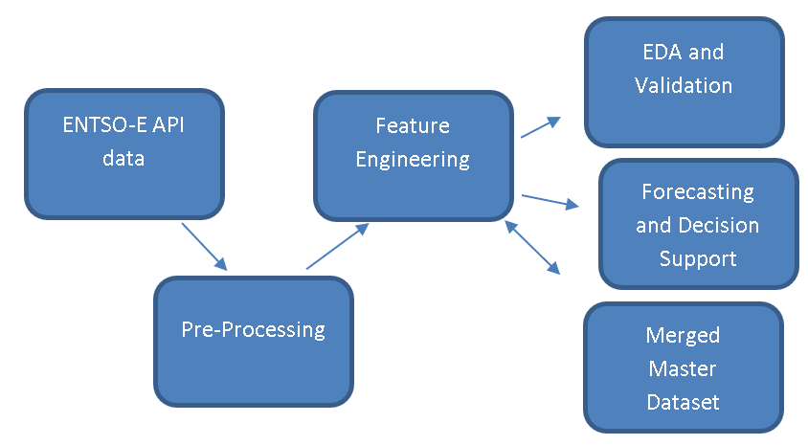
Figure 1: Summarised Technical Workflow

4.3 Technical Environment
Component | Choice
Programming language | Python 3.11+
Development environment | Jupyter Notebook
Core data libraries | pandas, NumPy
Data storage | Parquet via PyArrow
Visualisation | Matplotlib, Seaborn, streamlit
Statistical modelling | statsmodels
Machine learning | scikit-learn, XGBoost

4.4 Data acquisition

The first notebook simply acquires the raw datasets from ENTSO-E platform using their API. The country code is DE_LU represents the Germany-Luxembourg bidding zone. Data is requested for the period 1 January 2022 to 31 December 2024. Separate files are preserved for prices, load and generation so that the raw API responses remain traceable.
It is to be noted here that the generation data initially contained multiple production types and MultiIndex columns. Only Solar generation, wind onshore generation and wind-offshore generation were extracted. Total wind generation was created by summing the onshore and offshore series.
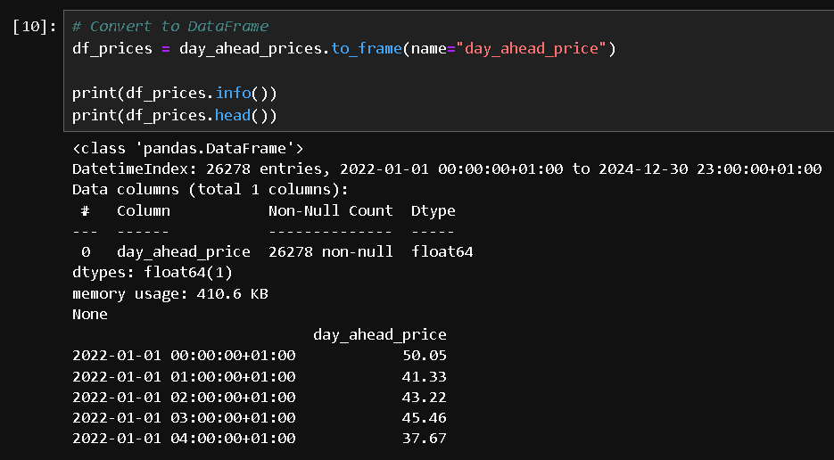
Figure 2: Screenshot of Price Data
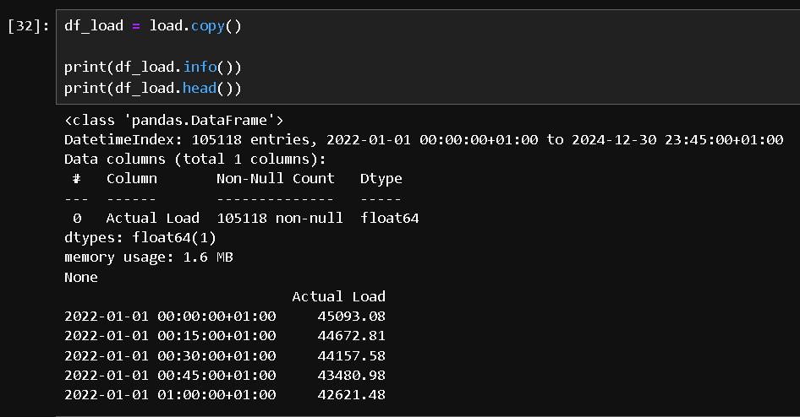
Figure 3: Screenshot of Load Data
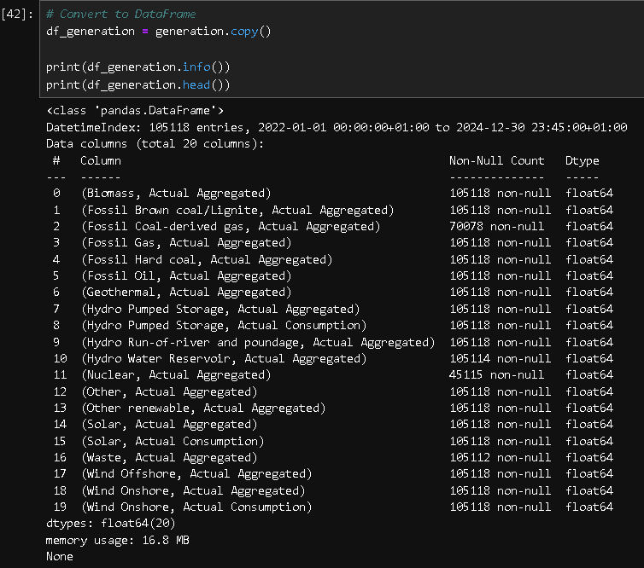
Figure 4: Screenshot of initial Generation Data

4.5 Data pre processing

This notebook cleans each raw dataset and saves them separately. It standardises naming, creates continuous time indexes, handles missing values and converts all time stamps to UTC. UTC conversion is very important here because Germany observes daylight saving changes. This helps prevent ambiguous local timestamps and simplifies merging at the end. Step by step process involved:
- Inspect dataframe structure, data types, index frequency and missing values.
- Convert 15-minute load and generation observations to hourly means.
- Reindexing each dataset to a continuous hourly time range.
- Apply time based interpolation .
- Convert the hourly time index from to UTC.
By the end of this stage, there are cleaned price data, load data and generations data. The pricing dataset contains 26,280 continuous hourly observations. The load data and renewable generation datasets were also reduced to the same hourly time base. The power generation table also contains solar_generation and wind_generation after aggregation.
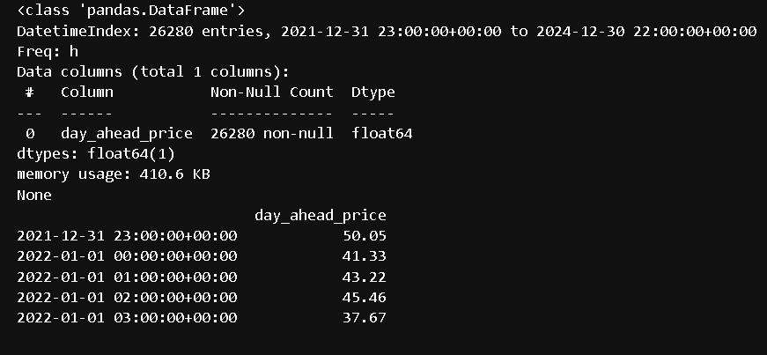
Figure 5: Cleaned Price Data
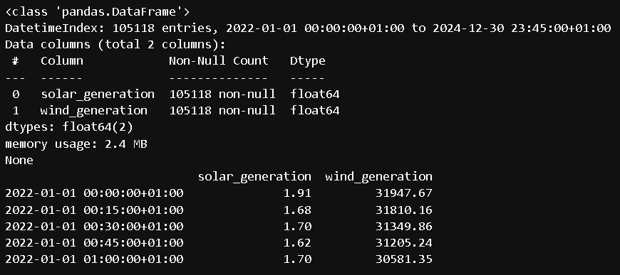
Figure 6: Cleaned Generations Data

4.6 Feature engineering

In this notebook, new feature are derived from existing data on the basis of domain informed derivations for variables that reflect electricity market behaviour. Such as, Lag features represent market memory (i.e. short term memory), rolling statistics represent the recent market state, ramps represent changes in demand or renewable generation output, and cyclical time encodings represent recurring patterns without treating midnight as numerically far away from 23:00.
The renewable share feature is calculated as (wind generation + solar generation) / load. The ratio is useful because a fixed amount of renewable output may have a different market effect depending on system demand at that particular time/moment. (Wissel, Spanca and Rudion, 2025) report that the renewable energy to load ratio is particularly influential in electricity price formation, which we further explore in correlational analysis in chapter 5.

4.7 Data merging

This notebook simply joins the engineered price, load and generation tables on the UTC timestamp index. The common timestamp intersection is used and retained so that all rows have complete values. Features such as renewable share, are added after merging all the datasets.
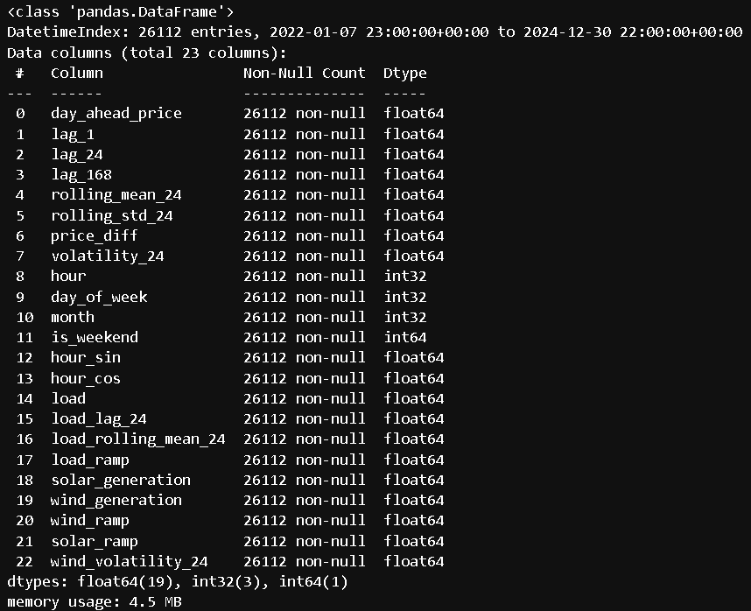
Figure 7: Final Merged Data

5. Exploratory Data Analysis

Exploratory data analysis is an important step in this project, as it helps to understand the behaviour of day ahead electricity prices before moving into model development. The main purpose of this stage is to identify key market characteristics that support the choice of forecasting features and provide a foundation for the later modelling and decision support.
In line with the project objectives, the EDA focuses on four main areas that are day-ahead price dynamics, temporal market patterns, the relationship between prices and other variables, and volatility behaviour. These analyses provide initial evidence for RQ1 and RQ2. However, the final assessment of feature contribution is carried out later in Chapter 8 through model based feature importance and forecasting performance comparison.

5.1 Day ahead Price Dynamics
Figure 2 below presents the daily average German day ahead electricity price together with a 30-day rolling average. The prices look unstable in 2022, with several extreme price occasions and a peak around late summer 2022. This period is clearly separated from the later years, as prices clearly stabilise during 2023 and 2024. Although some short term spikes remain visible in 2024, but the overall price level is much lower than during the 2022 crisis period. This finding supports the choice of the period from 2022 to 2024 because it captures both an extreme market-disruption phase and the subsequent stabilisation phase.
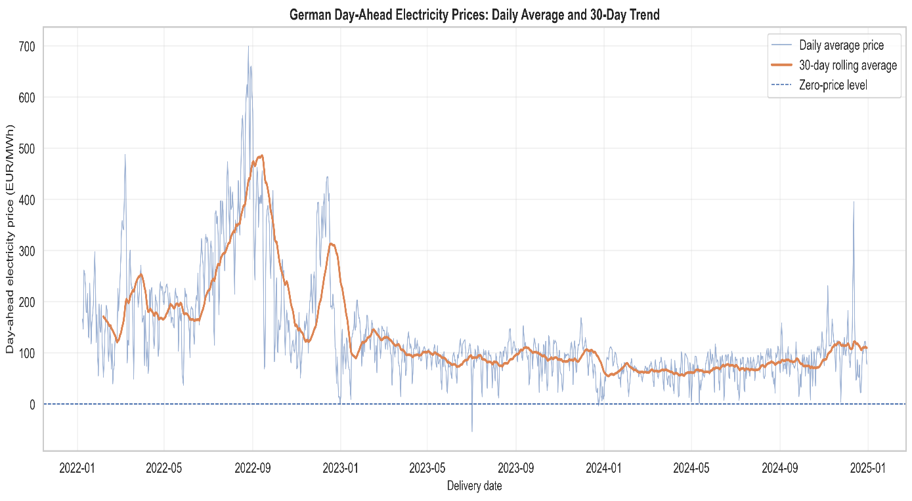
Figure 8: Daily average German day ahead electricity prices and 30-day rolling trend
The 30-day rolling average in red shows the transition from very high prices in 2022 to more moderate price levels in 2023 and 2024. This is important observation because it suggests that the model should be able to handle non stationary behaviour, alternating markets and occasional price shocks/peaks. Such characteristics are common in electricity price forecasting literature, where electricity prices are described as volatile, seasonal and prone to extreme events (Weron, 2014; Maciejowska, Uniejewski and Weron, 2022).

5.2 Price Distribution and Extreme Values

Figure 3 below shows the distribution of hourly day ahead prices in both actual scale and also after applying asinh transformation. The actual distribution indicates that most hourly prices are concentrated within a relatively narrow positive range, but the distribution is strongly right-skewed due to price spikes. This simply means that a small number of extreme observations have a large impact on the overall price distribution. The distribution also includes values close to zero and negative prices, which are important characteristics of electricity markets which have high renewable generation penetration.
The asinh transformation is applied because it behaves similarly to a logarithm for large values yet remains valid for zero and negative values. Negative values as we know are a unique characteristic of electricity markets. This makes the transformed distribution more readable without excluding economically meaningful negative price observations.
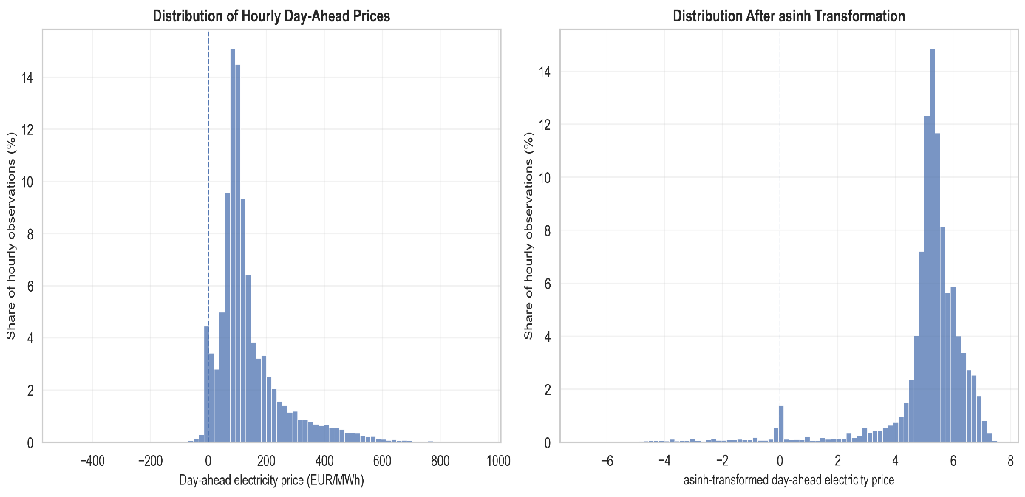
Figure 9: Distribution of hourly day ahead prices before and after inverse hyperbolic sine transformation
The distribution above tells us that German day ahead electricity prices are not normally distributed. This in turn supports the inclusion of flexible machine learning models such as Random Forest and XGBoost. It also justifies the use of error metrics such as MAE and RMSE later on.

5.3 Temporal Price Patterns
Figure 4 below gives us the average day ahead electricity price by delivery hour and the day of the week. The heatmap clearly shows the temporal structure. Prices are generally higher during weekday mornings and in the evening periods, while weekend and Sunday afternoons prices are noticeably lower. This is gives a hint that industrial and commercial demand is typically stronger during working days, while weekend demand is lower because most industries and commercials are closed.
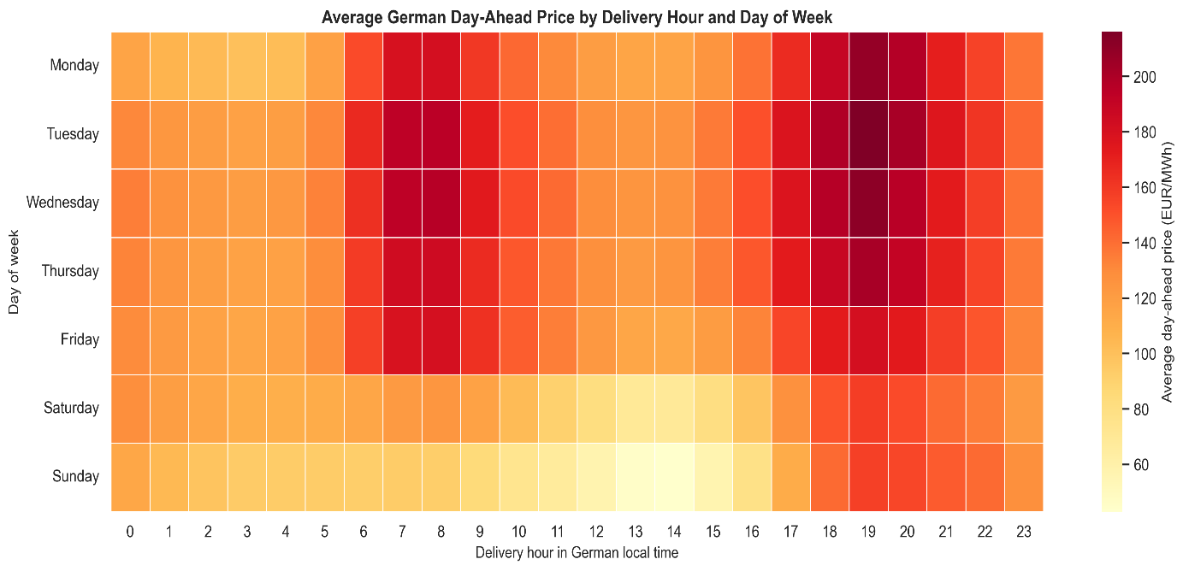
Figure 10: Average German day ahead price by delivery hour and day of week
This heatmap in figure 4 above provides direct justification for including features such as hour, day of week, weekend indicator and cyclical hour encoding in the modelling dataset. These represent systematic market behaviour. The observed hourly and weekly patterns also support the inclusion of lag features such as lag_24 and lag_168, since electricity prices often display daily and weekly repetition. So, it can be concluded that the temporal EDA supports Objective 3 as it showing that time based variables are economically meaningful predictors.
Figure 5 below goes a step further and compares monthly average prices across the 3 years of choice. It shows that 2022 was substantially different from the following years, especially during summer and early autumn. 2023 and 2024 on the other hand display lower and more stable monthly average prices. This strengthens the argument that the dataset contains different price brackets and that the forecasting model must generalise across changing market conditions.
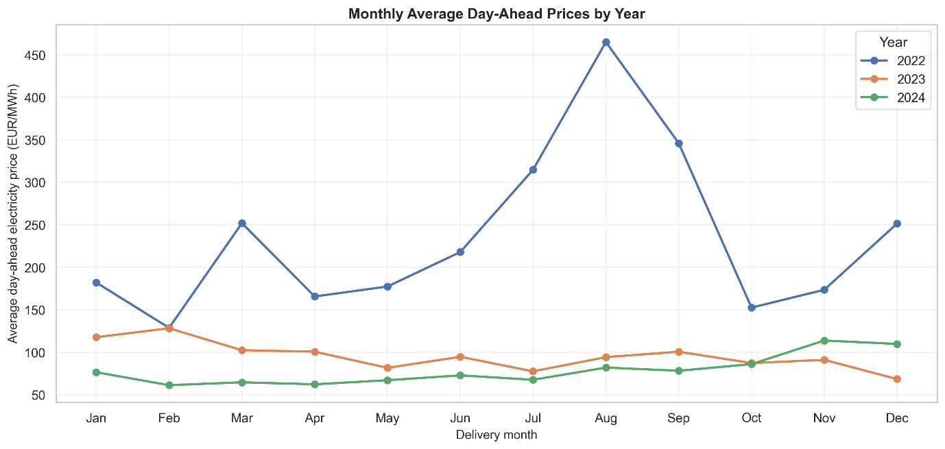
Figure 11: Monthly average day ahead prices by year

5.4 Relationship Between Load and Prices
The relationship between actual load and day ahead price is shown in figure 6 below. A binned chart was preferred over a raw scatter plot because the dataset contains too many hourly observations, making a scatter plot crowded and difficult to interpret.
The relationship is generally positive. Load and median price seem to be directly proportional. This means that higher demand can require more expensive generation units to enter the merit order, causing increase in the MCP.
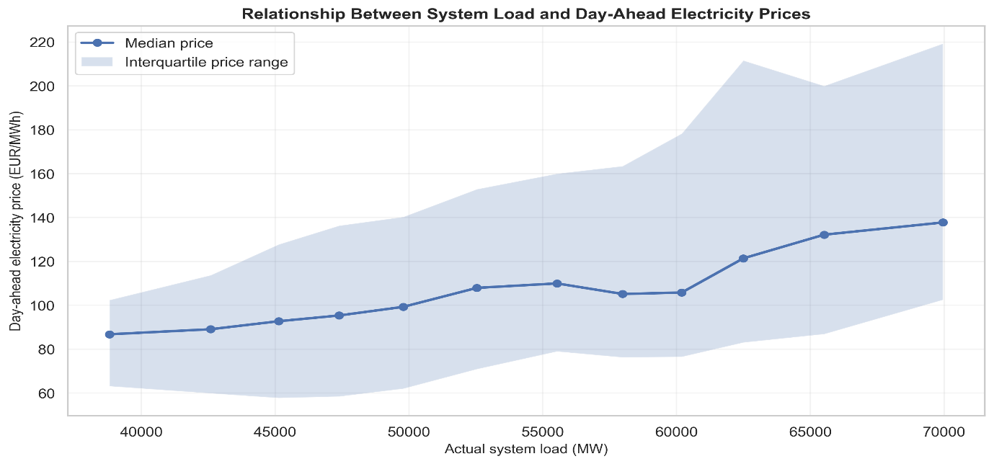
Figure 12: Relationship between system load and day ahead electricity prices
This finding supports the inclusion of load related features such as actual load, load_lag_24, load_rolling_mean_24 and load_ramp. However, it must be noted that the current EDA uses actual load values. For a fully operational day ahead forecasting system, only variables available before gate closure, forecast values, or appropriately lagged actual values should be used to avoid data leakage.

5.5 Renewable Share and Price Behaviour
In Figure 7 the relationship between renewable share and day ahead electricity prices can be seen. Because of high renewable penetration, this variable is particularly relevant for the German power market.
A negative relationship between renewable share and price can be seen. Hence, they can be said to be inversely proportional. This pattern proves the merit order effect, where wind and solar generation have low marginal costs and can reduce the need for costly conventional generation. So, it is safe to say that higher renewable generation can suppress wholesale electricity prices.
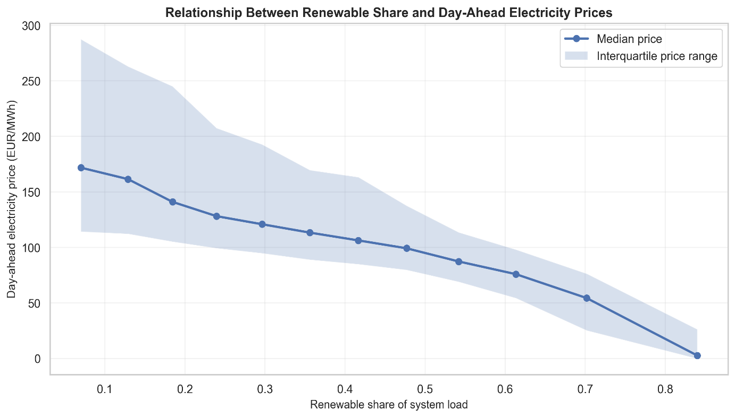
Figure 13: Relationship between renewable share and day ahead electricity prices
This is one of the most important findings for the project. It directly supports Objective 1, and Objective 3,. It somewhat also provides evidence for RQ2 by showing that renewable share is likely to be an important explanatory variable.

5.6 Feature Association Analysis
Pearson and Spearman correlations between selected features and the price are compared in Figure 8. lag_1, rolling_mean_24, lag_24 and lag_168 are the features that show the strongest positive associations. This is an indication towards strong price persistence and supports the use of autoregressive lag features in the forecasting model.
The chart also shows that renewable_share and wind_generation are negatively associated with price, while load has a weaker but positive relationship.
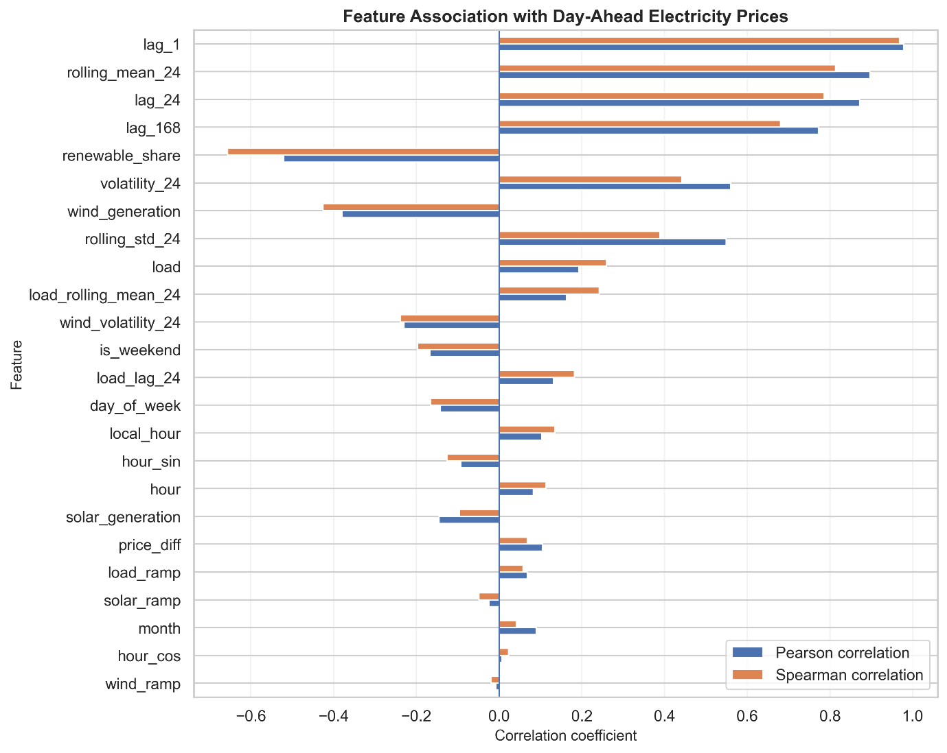
Figure 14: Feature association with day ahead electricity prices
The following Figure 9 provides a focused Spearman correlation heatmap for the key market variables. This heatmap also shows that the prices are strongly correlated with lag_1, lag_24, lag_168 and rolling_mean_24. It also shows a strong negative relationship between renewable_share and day_ahead_price. Wind_generation is also negatively related to price, while volatility_24 is positively associated with price.
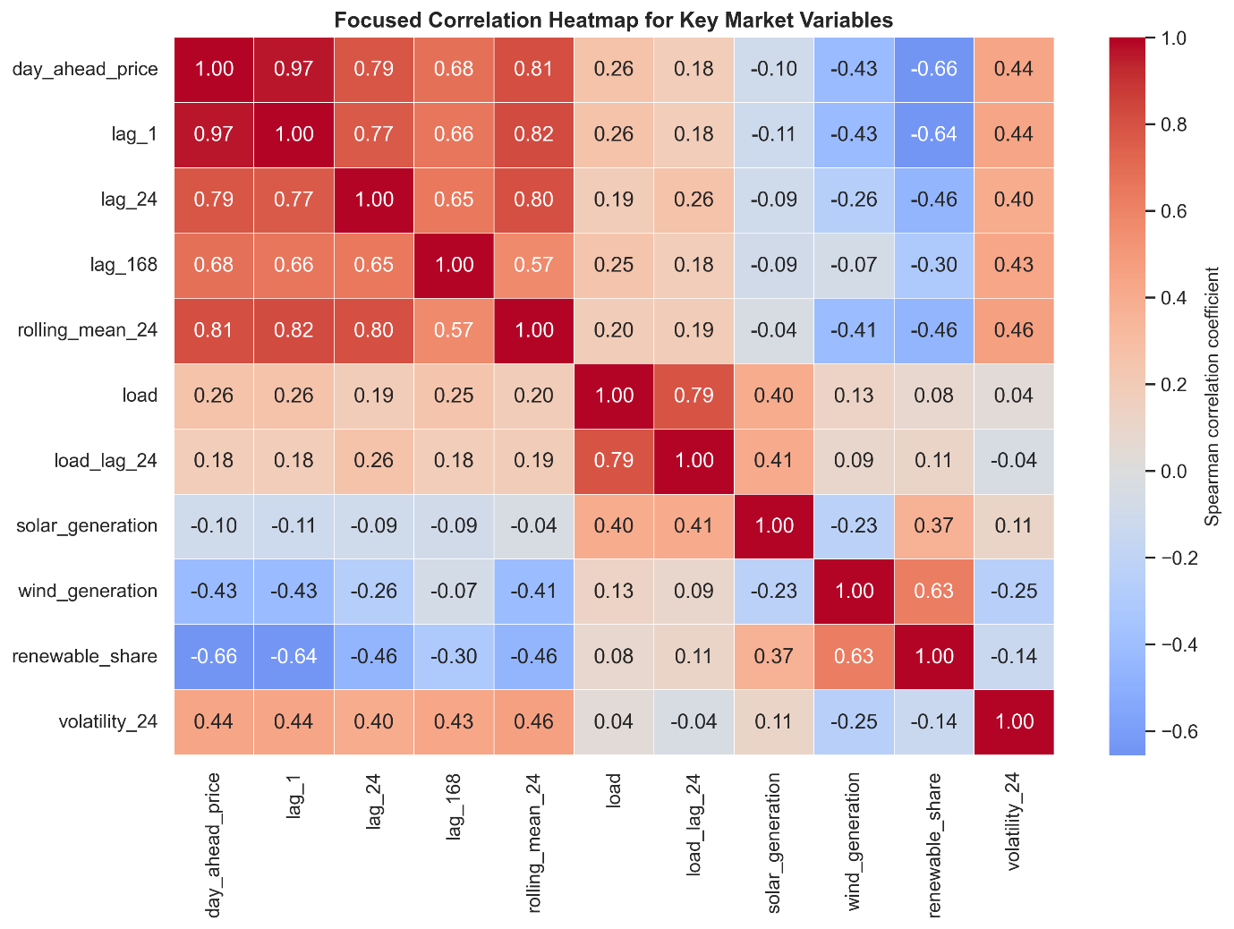
Figure 15: Focused correlation heatmap for key market variables
Pearson correlation captures only linear relationships, while tree based models such as Random Forest and XGBoost can identify non-linear relationships. Even though this correlation provides an initial understanding of feature relevance, but the final answer to RQ#2 will be done later in model based feature importance and permutation importance after training part.

5.7 Price Volatility
Figure 10 shows the rolling volatility of prices, measured using the daily average of 24 hour rolling volatility. Volatility was particularly high during 2022, same as the extreme price dynamics observed in the price trend chart. It declined during 2023 and 2024, although several sharp volatility spikes appeared again in late 2024. This means that the market stabilised during later years.
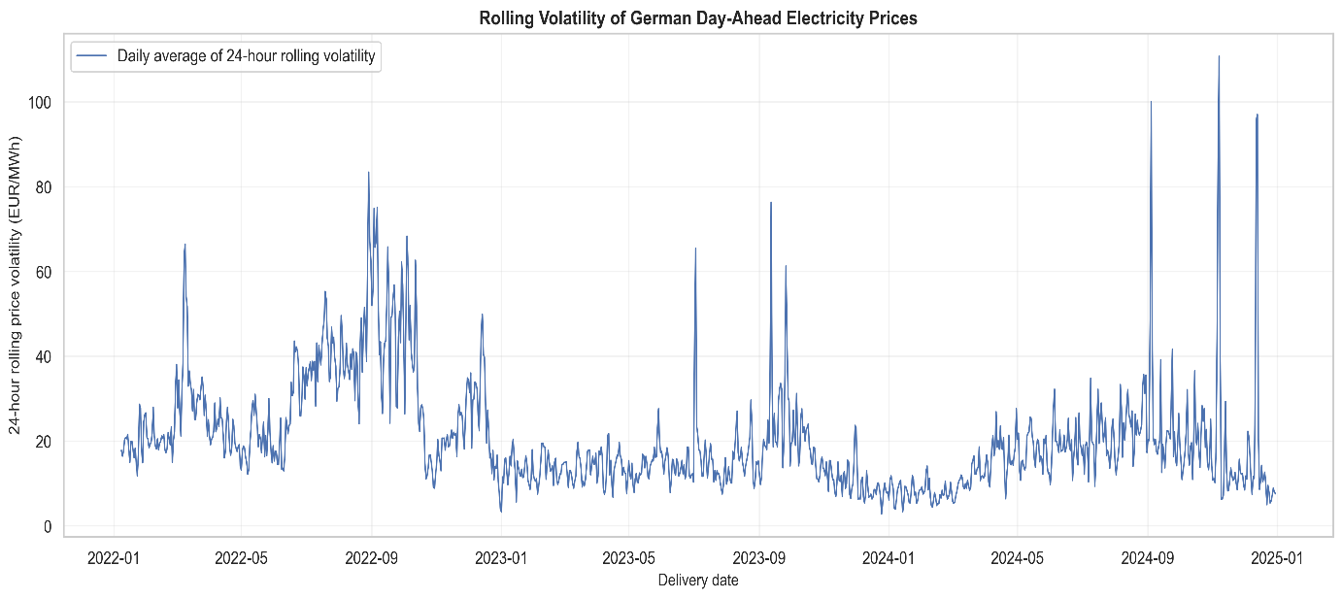
Figure 16: Rolling volatility of German day ahead electricity prices
This finding is important when considering both forecasting and decision support. Highly volatile periods are generally more difficult to forecast accurately because prices are changing rapidly and have sudden spikes. Later, in the decision support layer, volatility can be used as a risk signal. For example, when forecasting uncertainty or recent volatility is high, the system may recommend a more cautious decision such as “hold” rather than a strong buy or delay recommendation.

5.8 Summary of EDA Findings
The analysis in this chapter confirms that German day ahead electricity prices display several characteristics that make forecasting valuable but challenging. First of all, prices changed significantly between 2022 and 2024. There were extreme levels and volatility during 2022 followed by more stable conditions in 2023 and 2024. Secondly, the distribution of prices is skewed and contains extreme values, supporting the use of flexible forecasting models such as XgBoost. Thirdly, strong temporal patterns are visible across hours and days of the week, justifying the inclusion of temporal and lagged price features which is essential in terms of domain. Fourthly, load is positively related to electricity prices, while renewable share is strongly negatively related to prices, which proves the idea that increase in demand causes hike in price, while increase in renewable energy penetration decreases the prices. Lastly, volatility varies substantially over time and may be useful for both forecasting evaluation and decision support logic.
Overall, the EDA shows support for RQ1 by identifying lagged prices, renewable share, wind generation, load and temporal patterns as potentially important explanatory variables. However, the final assessment of their contribution to forecasting performance will be completed during the model evaluation and feature importance stages.

6. Forecasting Model Development and Evaluation
This section presents the development and evaluation of forecasting models for German day ahead electricity prices. The modelling stage answers the RQ#2. It also answers part of to RQ#1 through model based feature importance analysis.
This chapter focuses on comparing simple benchmark approaches with machine learning models. It also assess whether engineered features improve forecasting performance or not. All the models were trained using data from 2022 and 2023 and evaluated on an unseen test period covering 2024.

6.1 Modelling Dataset and Leakage Safe Feature Preparation
The modelling dataset contained 25,944 hourly observations after removing rows with missing values caused by lag and rolling-window feature construction. The training set covered the period from 15th January 2022 to 31st December 2023 and contained 17,184 observations. The test set covered 1st January 2024 to 30th December 2024 and contained 8,760 observations.
In a forecasting task, the model should only use information that would have been available before the target hour. Therefore, price rolling features were recalculated using shifted values. For example, the 24-hour rolling average of price was calculated from previous observations only, rather than including the current target hour. Similarly, actual load, wind and solar values were not used directly for the same hour in the main feature set. Instead, lagged versions of load and renewable variables were used. This made the evaluation more conservative and more realistic than using actual explanatory variables in the same hour.
The final set of features included four main categories:
The memory features: ‘price_lag_1’, price_lag_24, ‘price_lag_1’68 and rolling price statistics.
Temporal features: hour, day of week, month, weekend indicator and cyclical encodings.
Lagged load features:including load_lag_24, load_lag_168 and load rolling statistics.
Lagged renewable features:including wind, solar and renewable share lagged indicators.
This feature design reflects the findings of the EDA stage, where price persistence, temporal patterns, load and renewable penetration were shown to be relevant to price behaviour.

6.2 Evaluated Models
The five compared approached are as follows:
- Naive baseline: same hour previous day
- 24-hour rolling mean baseline
- Autoregressive statistical baseline
- Random Forest Regressor
- XGBoost Regressor
The naive baseline is important because day ahead electricity prices often show strong daily repetition as it can be seen in the correlational analysis in the EDA stage. A forecasting model must outperform this simple benchmark to demonstrate practical value. The rolling mean baseline provides a smoothed historical-price benchmark. Random Forest and XGBoost were selected because tree-based ensemble models can capture non linear relationships, threshold effects and interactions between explanatory variables. These properties are very useful in electricity markets, where price formation is influenced by a combination of historical prices, load, renewable generation and temporal effects. Recent electricity price forecasting studies also show that ensemble machine learning models often perform strongly in day ahead forecasting tasks (Lehna, Scheller and Herwartz, 2022; Wissel, Spanca and Rudion, 2025).
The autoregressive statistical baseline was also tested. However, the initial implementation produced an unrealistically poor result during the long out-of-sample test period.

6.3 Evaluation Metrics
The models were evaluated using MAE, RMSE, sMAPE, WAPE and R² metrics. MAE was used as the primary metric because it is easy to interpret it in the original unit of the target variable, EUR/MWh. RMSE was also included because it focusses on large errors more strongly and is therefore useful for electricity price forecasting, where spikes can be economically important. WAPE was included as a percentage-based aggregate error measure, while R² was used to assess the proportion of variance explained by the model.
Because electricity prices can be close to zero or negative, conventional MAPE can be misleading. For this reason, sMAPE and WAPE were preferred over standard MAPE.

6.4 Performance Results of Models
Table 2 gives a summary of forecasting performance of evaluated models:
Model | MAE (EUR/MWh) | RMSE (EUR/MWh) | sMAPE (%) | WAPE (%) | R²
XGBoost | 7.49 | 14.76 | 20.59 | 9.39 | 0.922
Random Forest | 7.71 | 15.56 | 19.95 | 9.67 | 0.913
Naive: same hour previous day | 27.85 | 44.35 | 52.68 | 34.92 | 0.294
Rolling mean 24h baseline | 28.38 | 42.72 | 47.58 | 35.59 | 0.345
Autoregressive statistical baseline | 597.36 | 762.12 | 198.38 | 748.97 | 207.55
Table 2: Model comparison on the 2024 test set
The results show that both machine learning models substantially outperformed the naive and rolling mean baselines. XGBoost achieved the best overall performance with an MAE of 7.49 EUR/MWh, RMSE of 14.76 EUR/MWh and R² of 0.922. Random Forest performed very similarly, with an MAE of 7.71 EUR/MWh and R² of 0.913. The small difference between XGBoost and Random Forest shows that both ensemble based approaches were able to capture the major price patterns in the dataset.
The naive baseline had an MAE of 27.85 EUR/MWh, while the rolling mean baseline had an MAE of 28.38 EUR/MWh. Compared with the naive baseline, XGBoost reduced MAE by approximately 73.1%. This provides strong evidence that the engineered feature set and machine learning approach improved forecasting accuracy.
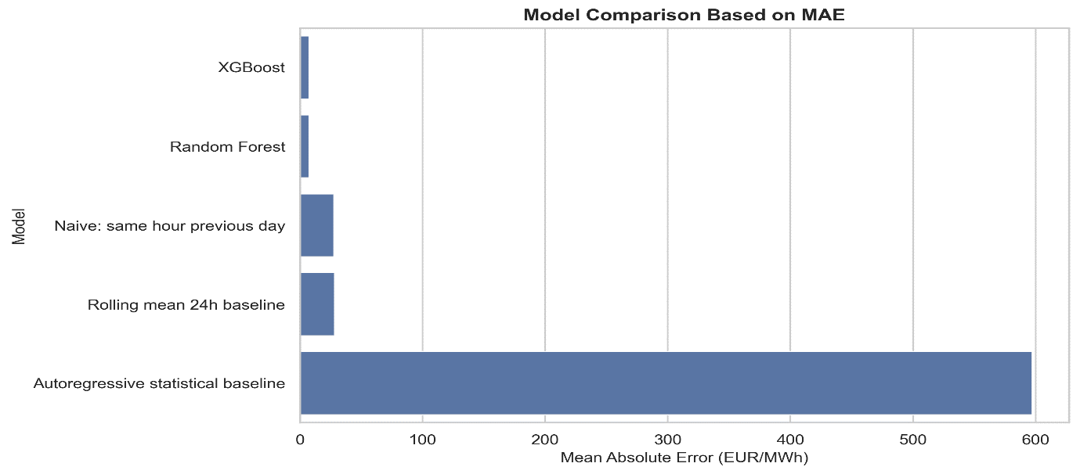
Figure 17: Model comparison based on MAE:
The model comparison chart in figure 11 clearly shows that XGBoost and Random Forest produced much lower MAE values than the simple benchmark models. However, the autoregressive statistical baseline should not be interpreted as evidence that all statistical models perform poorly as of yet. Rather, its result reflects the need for a more appropriate rolling statistical implementation.

6.5 Actual vs Predicted Price Behaviour
The following Figure 12 on the next page compares actual and predicted day ahead prices for January 2024. This shorter period was selected to make the time series comparison visually readable.
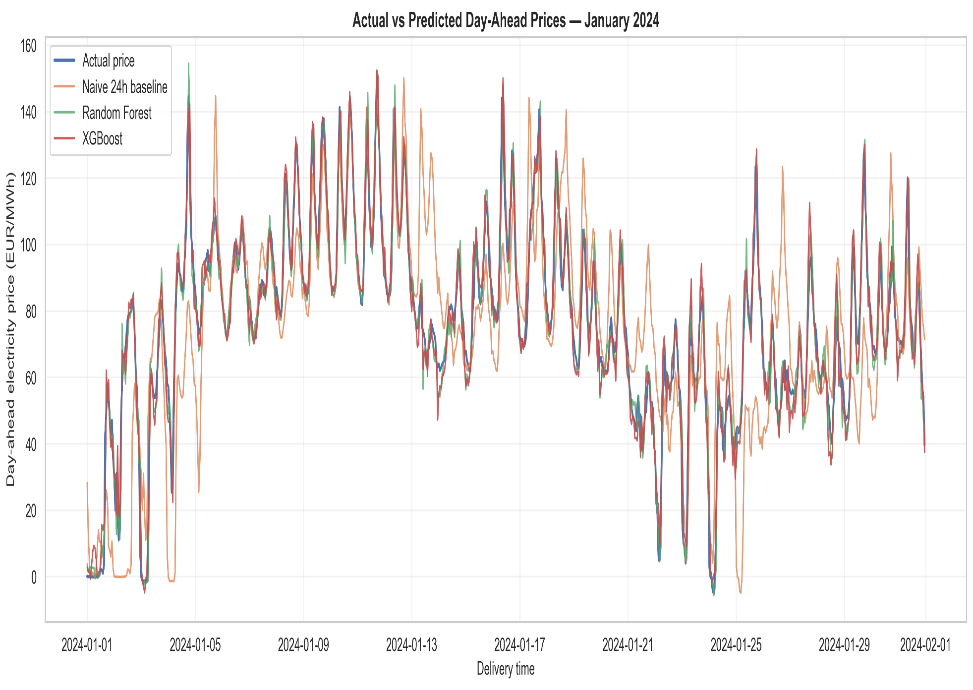
Figure 18: Actual vs predicted day ahead prices for January 2024
The XGBoost and Random Forest closely follow the actual price trajectory for most of the month. Both models captured the daily price movement and many of the short term fluctuations. Talking about the other models, the naive 24-hour baseline deviates more a lot, especially when the price pattern changes from one day to the next. This illustrates why simple same hour and previous day(lagged values) forecasting is not sufficient under changing market conditions.
The close results of machine learning predictions and the actual price series supports the results in Table 2. It means that the models are not only reducing average error but are also learning the temporal structure of day ahead prices.

6.6 Forecasting Error Analysis
The residual analysis of the XGboos model also provides insight into model performance. Figure 13 shows the distribution of XGBoost forecasting errors.
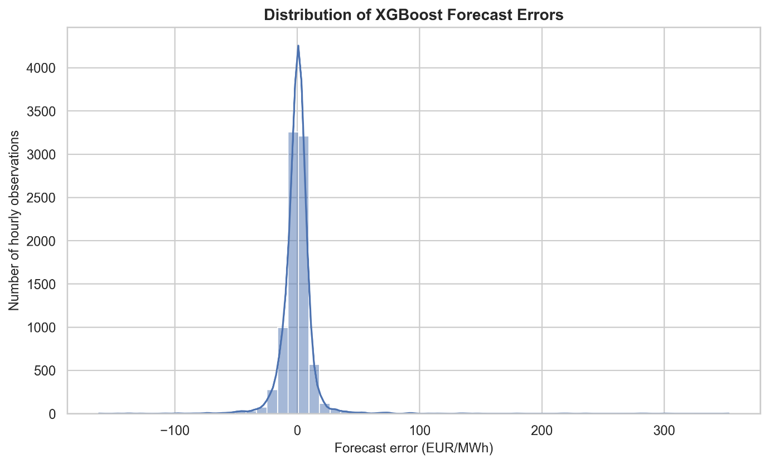
Figure 19: Distribution of XGBoost forecasting errors
Most hourly predictions are close to the actual price as they are close to zero. However, the distribution also contains long tail, which hints towards large forecasting errors. In electricity price forecasting which usually has sudden price spikes, this is something that is expected.
Figure 14 shows XGBoost forecasting errors across the full 2024 test period.
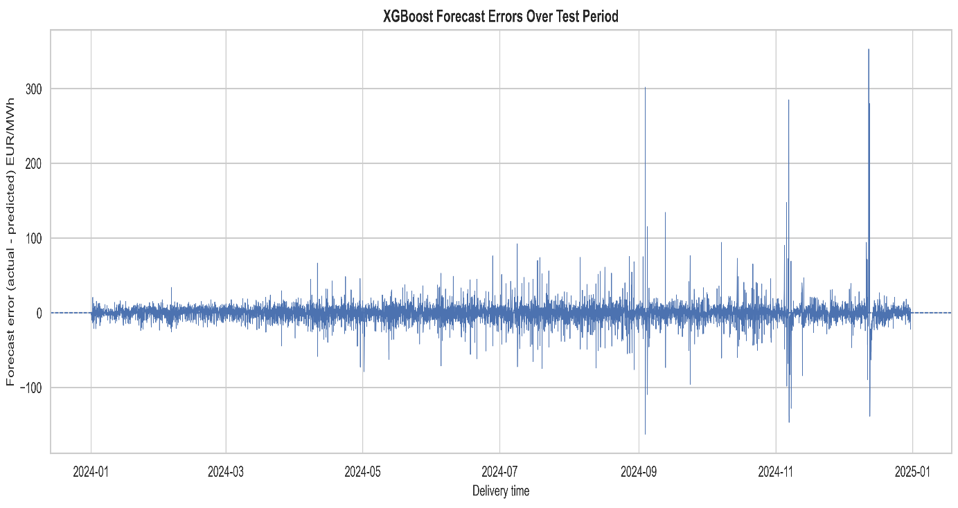
Figure 20: XGBoost forecasting errors over the test period
Most errors are close to zero throughout, but several large error spikes can be visualised. Positive errors indicate cases where the actual price was higher than the predicted one. Similarly, negative errors indicate over prediction.
This suggests that future development should not only focus on average accuracy but also on identifying high risk periods. A decision support system can use forecasting errors, volatility indicators or prediction uncertainty to flag periods where recommendations should be done carefully.

6.7 Feature Importance Analysis
Feature importance analysis as mentioned earlier is performed here using the trained XGBoost model. This analysis contributes to RQ#2 by identifying which engineered variables were most influential in the forecasting model.
Figure 15 shows the built-in XGBoost feature importance scores.
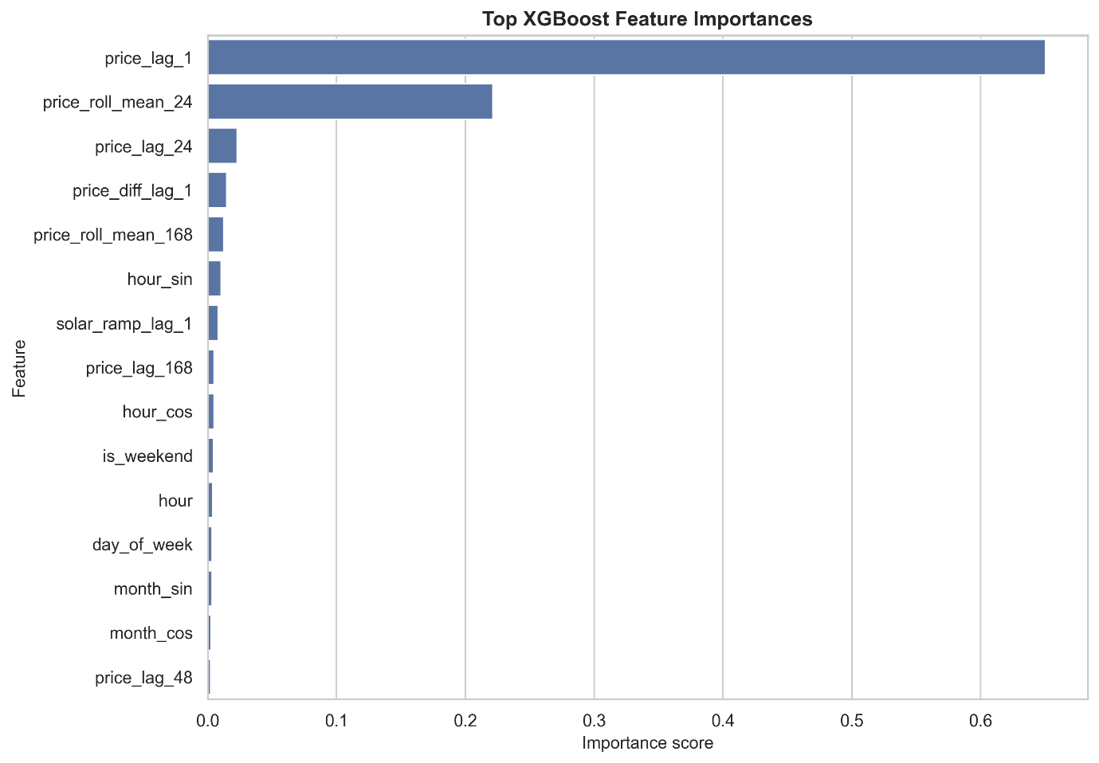
Figure 21: Top XGBoost feature importances
The most important feature turned out to be ‘price_lag_1’, followed by ‘price_roll_mean_24’. This means that the model relied heavily on very recent price information and the recent 24-hour price level. Other somewhat influential features included price_lag_24, price_diff_lag_1, price_roll_mean_168 and cyclical time features such as hour_sin and hour_cos.
The result above is same as what was seen in the EDA stage, where lagged prices showed strong correlation with the target variable. It also aligns with electricity price forecasting literature, where autoregressive price behaviour and daily/weekly seasonality are widely recognised as central characteristics of short term electricity prices (Weron, 2014; Maciejowska, Uniejewski and Weron, 2022).

6.8 Interpretation in Relation to the Research Questions

The modelling results provide a clear answer to RQ#2. XGBoost and Random Forest which are ML models, forecasted the prices with substantially higher accuracy than simple benchmark methods. XGBoost achieved the best result, with an MAE of 7.49 EUR/MWh and R² of 0.922 on the 2024 test set.
The analysis for feature importance provided an initial model based answer to RQ#2. Price memory features were the most influential, especially ‘price_lag_1’ and ‘price_roll_mean_24’. Temporal features were also effective, while renewable and load variables had smaller effect in the current lagged feature setup. This could mean that the model’s memory prices already have the effect of these and replicate it further already.
However, RQ#3 and RQ#4 are not fully answered by the modelling stage alone. Improved forecast accuracy must now be connected to a decision support framework. The next chapter will convert model forecasts into decision signal and also check whether those recommendations provide practical or economic value compared with benchmark strategies.

6.9 Summary of Modelling Findings

The modelling stage demonstrated that machine learning methods can provide accurate forecasts of day ahead electricity prices when supported by historical, temporal and market related features. XGBoost achieved the strongest performance, closely followed by Random Forest. Both of the regressor models substantially outperformed simple historical baseline models.
The results also showed that recent price behaviour is the strongest feature to predict the future day ahead prices. This finding directly supports the use of lagged and rolling price features. At the same time, the role of load and renewable generation should be revisited in future refinements using forecasted exogenous variables rather than lagged actual values.
Overall, the modelling results provided a strong foundation for the next stage which is to develop a decision support layer that converts forecasts into actionable recommendations and evaluates their practical value.

Decision support and Economic Evaluation

The results of the forecasts will now be turned into practical decision support. This is where this project varies from all other forecasting projects. Moreover. It will be examined if the results of the forecasts support economically meaningful decisions. This directly addresses RQ#3 and RQ#4.
It is to be noted here that this is designed to be scenario based decision support analysis instead of a full trading simulation. This seemed appropriate for the scope of the project because the aim is to demonstrate how forecasts can be converted into actionable recommendations. The scenario represents a flexible electricity consumer or procurement manager who can shift a limited amount of electricity demand away from forecasted expensive hours and into forecasted cheaper hours.

7.1 Decision support Logic

There is a possibility of three different and simple recommendations, which are as follows:
Reduce / Avoid: forecasted high price hours where flexible consumption should be reduced or avoided.
Shift / Buy: forecasted low price hours where flexible consumption should be shifted or increased.
Hold / Normal: all remaining hours where normal consumption should continue.
For each delivery day, the framework identifies the four forecasted most expensive hours and labels them as Reduce / Avoid. It also identifies the four forecasted cheapest hours and labels them as Shift / Buy. The remaining sixteen hours are labelled as Hold / Normal. This rule based design was chosen because it is transparent, easy to explain and suitable for decision makers.
XGBoost model was used as the primary forecasting model because it performed the best. Benchmark strategies were also evaluated using the naive previous day forecast, the 24-hour rolling mean forecast and the Random Forest forecast.

7.2 Scenario Assumptions
Simplified flexible load scenario is considered for economic evaluation. The baseline assumes fixed electricity consumption of 1 MWh per hour. Under the decision support strategy, 0.20 MWh of flexible consumption is reduced during each selected hour where the price is high and shifted into each selected hour where the price is low. Since four hours of high price and four of lower price are selected each day, the total daily energy consumption remains unchanged.
The calculation for cost is based on the actual observed price:
Hourly cost = Scheduled energy x Actual price
The total savings are calculated as:
Savings = Baseline cost - Strategy cost
If the saving is positive this means that the decision support strategy reduced electricity procurement cost compared with the fixed load baseline.
Other costs which will apply in realistic situation such as network charges, taxes, transaction costs, imbalance costs and technical constraints of specific industrial processes are excluded here. Therefore, the results should be interpreted as a scenario based estimate only of decision value rather than a complete trading simulation of a market.

7.3 Frequency of Recommendation
In the testing phase, the XGBoost decision support framework produces 8,760 hourly recommendations. Of these, 5,840 hours were classified as Hold / Normal, 1,460 hours were classified as Shift / Buy, and 1,460 hours were classified as Reduce / Avoid.
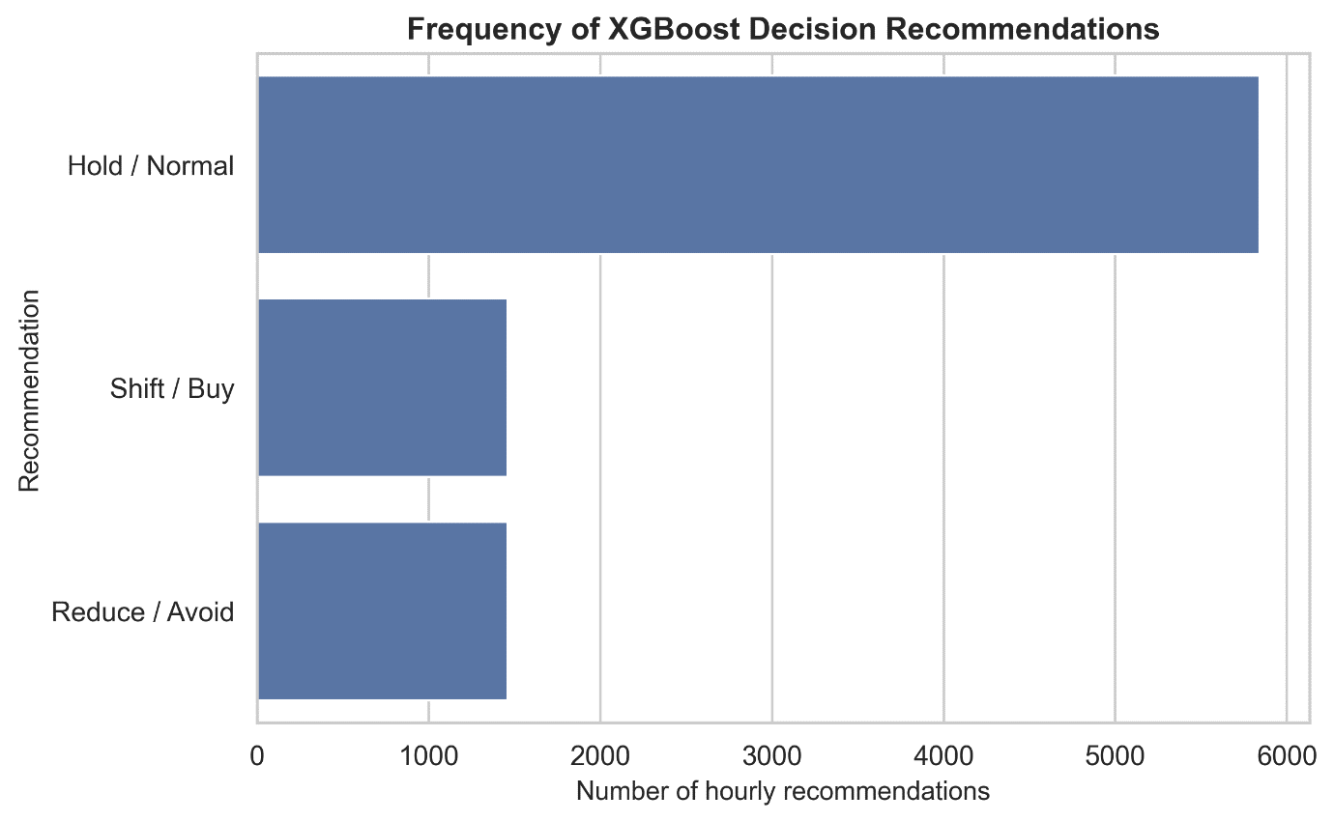
Figure 22: Frequency of XGBoost decision recommendations
This distribution is expected because the framework selects four low price and four high price hours per day. The remaining hours are left unchanged. This conservative structure is useful because it limits the number of active interventions and avoids overreacting to every hourly price change.

7.4 High-Price Detection Performance
A key requirement of the decision support system is its ability to identify expensive hours. High price detection was evaluated by comparing forecasted Reduce / Avoid recommendations with the actual top four price hours of each day.
The XGBoost model achieved the strongest high-price detection performance. It reached an accuracy of 93.45%, precision of 80.34%, recall of 80.34% and F1-score of 80.34%. Random Forest performed slightly lower, with an F1-score of 78.49%. The naive previous-day benchmark achieved an F1-score of 60.14%, while the rolling mean strategy performed poorly with an F1-score of 15.68%.
Strategy | Accuracy | Precision | Recall | F1-score
XGBoost | 0.9345 | 0.8034 | 0.8034 | 0.8034
Random Forest | 0.9283 | 0.7849 | 0.7849 | 0.7849
Naive 24h | 0.8671 | 0.6014 | 0.6014 | 0.6014
Rolling mean 24h | 0.7190 | 0.1568 | 0.1568 | 0.1568
Table 3: High-price detection performance
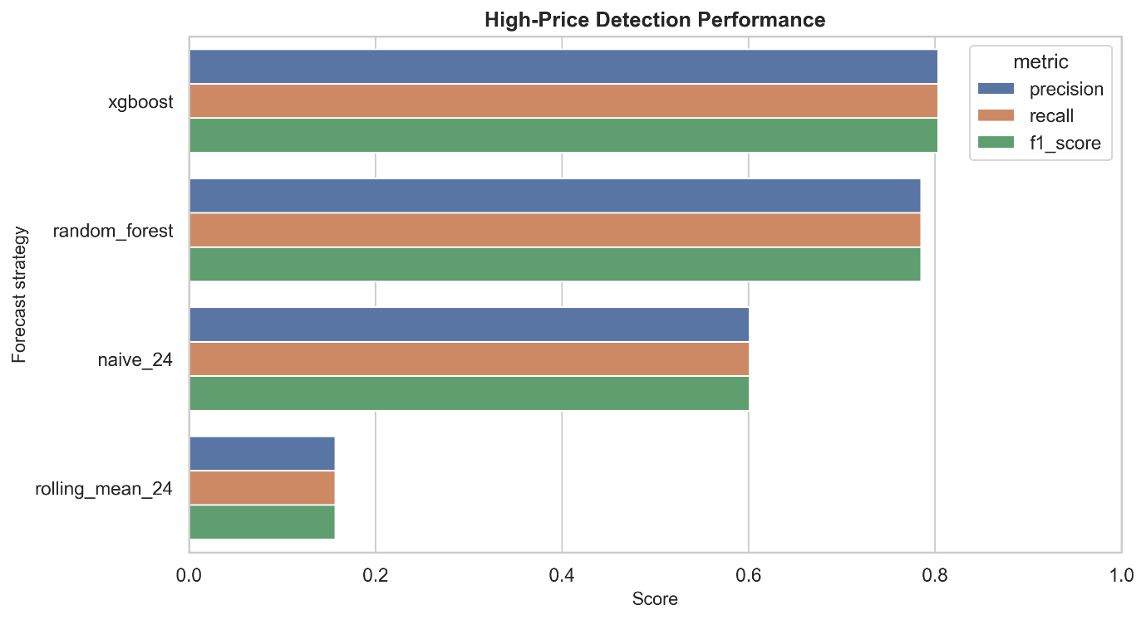
Figure 23: High-price detection performance
The XGBoost’s confusion matrix provides further detail. Out of 1,460 actual high price hours in the test period, XGBoost correctly identified 1,173. It missed 287 actual high price hours and incorrectly classified 287 normal hours as high price hours. The number of false positives and false negatives is equal because the framework always selects exactly four high price hours per day.
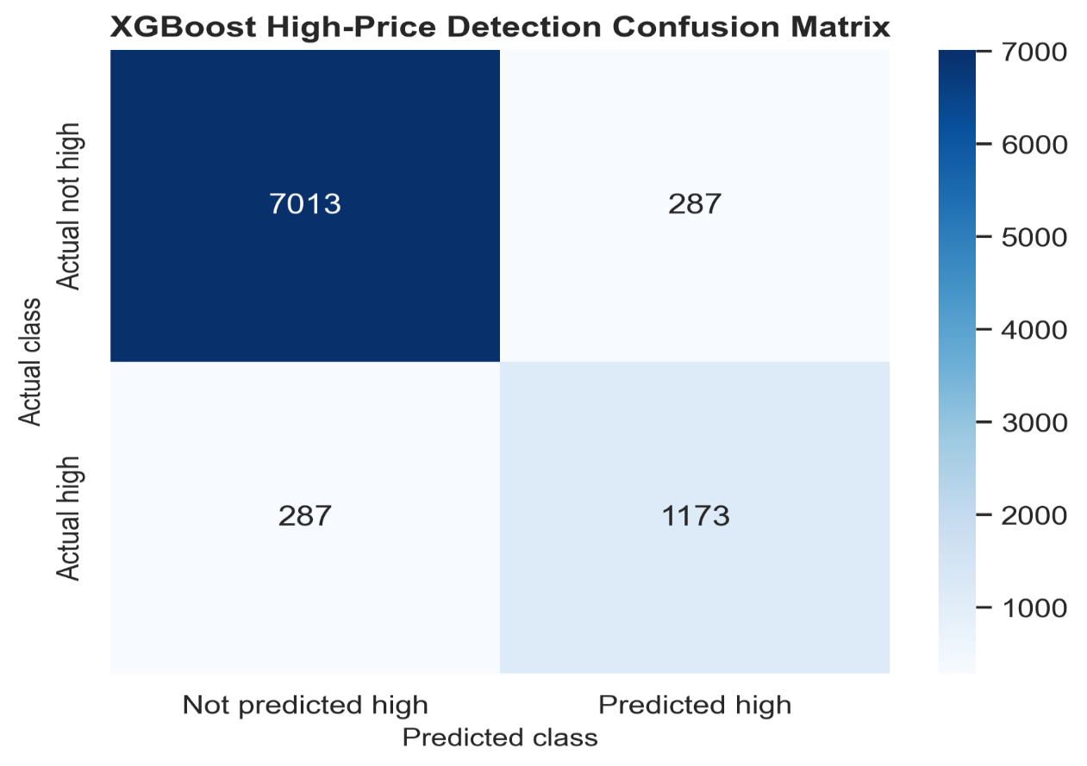
Figure 24: XGBoost high-price detection confusion matrix
These results show that the XGBoost model is not only accurate in terms of numerical forecasting error, but also effective at identifying the hours that matter most for decision making.

7.5 Directional Accuracy
This measure simply tells that if the direction of the signal was correct or not. It is important because many market decisions depend on whether the price is expected to increase or decrease relative to a benchmark. The forecasted price in this case is simply compared with the price which was at the same hour on the previous day.
Again XGBoost achieved the highest directional accuracy at 90.70%, followed closely by Random Forest at 90.09%. The rolling mean benchmark achieved only 64.63% directional accuracy.
Strategy | Directional accuracy
XGBoost | 0.9070
Random Forest | 0.9009
Rolling mean 24h | 0.6463
Table 4: Directional accuracy relative to previous-day price
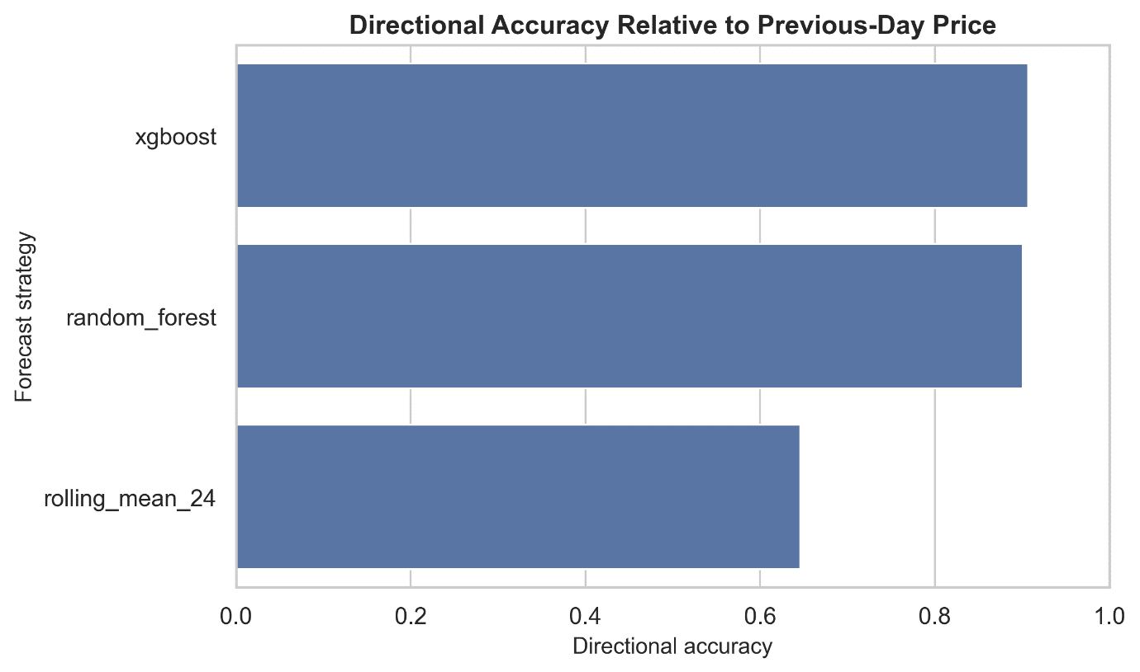
Figure 25: Directional accuracy relative to previous-day price
Decision support system does not only need exact price predictions, rather, it also needs to correctly identify whether prices are likely to be relatively high or low compared with a practical reference point. The high directional accuracy of XGBoost supports its use for recommendation generation.

7.6 Economic Evaluation
Each decision strategy was compared against a fixed load baseline. The baseline cost over the 2024 test period was €688,159.24. The decision according to XGboost reduced this cost to €663,304.55, producing total savings of €24,854.69 which is equivalent to 3.61% of the baseline cost.
Random Forest produced almost similar results, with savings of €24,705.27, or 3.59%. The naive previous-day strategy achieved savings of €20,336.17, or 2.96%. The rolling mean strategy achieved only €1,986.62, or 0.29%.

Strategy | Strategy cost (EUR) | Total savings (EUR) | Savings (%) | Positive-savings days
Oracle | 662,279.66 | 25,879.58 | 3.76% | 365 / 365
XGBoost | 663,304.55 | 24,854.69 | 3.61% | 365 / 365
Random Forest | 663,453.97 | 24,705.27 | 3.59% | 365 / 365
Naive 24h | 667,823.07 | 20,336.17 | 2.96% | 355 / 365
Rolling mean 24h | 686,172.62 | 1,986.62 | 0.29% | 208 / 365
Table 5: Economic evaluation summary
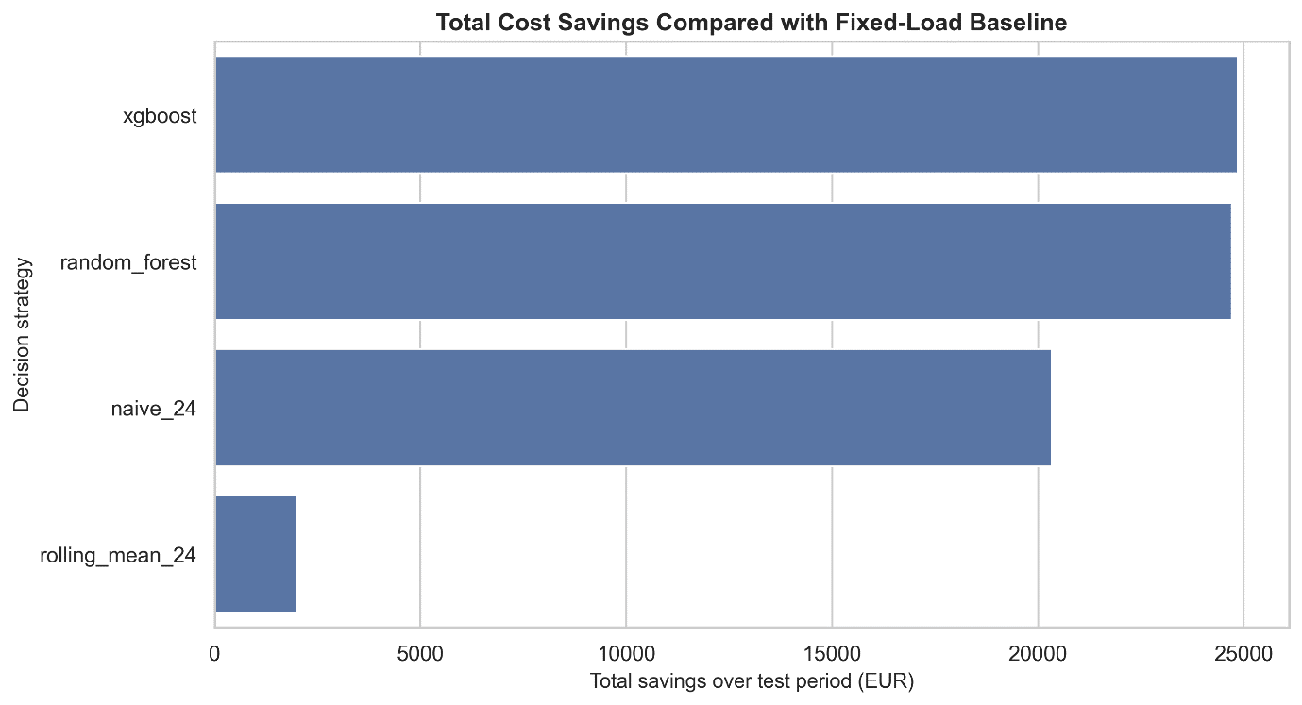
Figure 26: Total cost savings compared with fixed-load baseline

7.7 Cumulative Savings Over Time
Figure 22 shows cumulative savings over the full 2024 test period. The XGBoost and Random Forest strategies produce steadily increasing savings throughout the year and remain close to the oracle upper bound. The naive strategy also generates positive savings but remains clearly below the machine learning strategies. The rolling mean strategy produces only limited economic value.
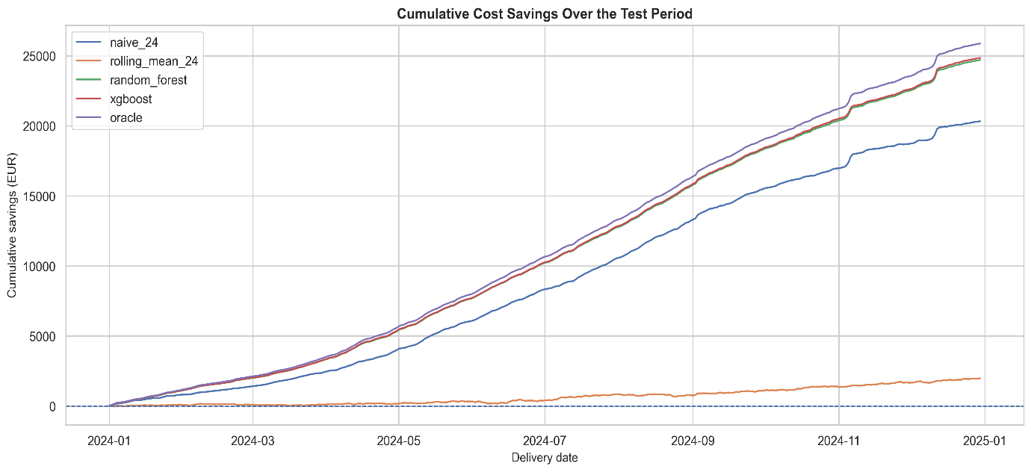
Figure 27: Cumulative cost savings over the test period
This result is important because it shows that the savings are not caused by a single isolated event. Instead, the XGBoost strategy generates consistent value across the year. The daily savings distribution confirms this pattern. The XGBoost strategy achieved positive savings on 365 out of 365 days, with average daily savings of €68.10 and median daily savings of €61.13.
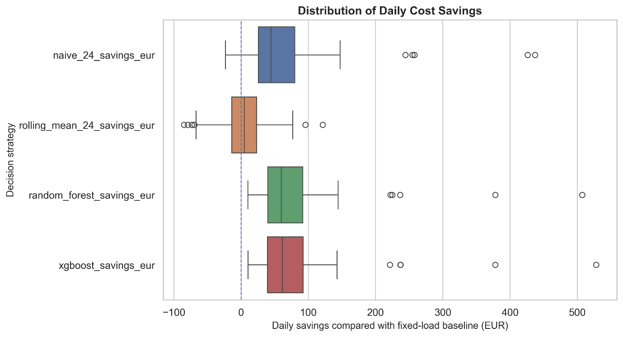
Figure 28: Distribution of daily cost savings
The daily savings distribution in Figure 23 also shows that XGBoost and Random Forest have similar performance profiles, while the rolling mean strategy is less reliable and produces negative savings on many days.

7.8 Example of Decision Recommendations
Figure 24 illustrates XGBoost’s recommendations over the first two weeks of January 2024. The chart overlays actual prices, XGBoost forecasts and the generated recommendations. The Reduce / Avoid recommendations generally appear near daily price peaks, while Shift / Buy recommendations appear near lower price periods.
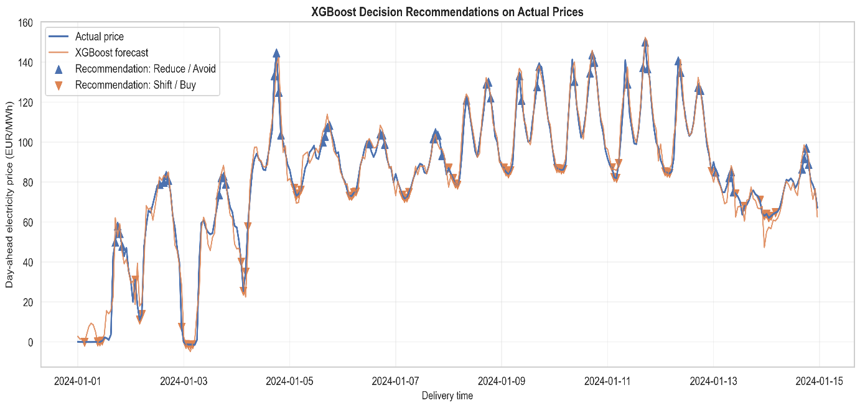
Figure 29: XGBoost decision recommendations on actual prices
This demonstrates the practical interpretability of the framework. Instead of presenting users with only a forecasted price, the system translates the forecast into clear operational guidance. This supports the objective of developing a transparent decision support layer rather than simply producing a prediction model.

7.9 Interpretation of Practical Value
XGBoost had the best forecasting performance in the modelling stage and also produced the highest economic savings among the feasible strategies. Its high price detection F1-score of 80.34%, directional accuracy of 90.70% and total savings of €24,854.69 demonstrate that the model can support useful procurement decisions.
The comparison with benchmark strategies is important. The naive previous-day strategy produced some savings because electricity prices have strong daily patterns. However, XGBoost improved on this benchmark by approximately €4,518.53 over the test period. The rolling mean strategy performed poorly, suggesting that simple smoothing does not provide enough information for effective decision-making. Random Forest performed close to XGBoost, which confirms that ensemble-based machine learning models are suitable for this type of decision support application.
The findings also show that decision value is not determined only by average forecast accuracy. What matters for this scenario is whether the model can correctly rank high-price and low-price hours within each day. XGBoost performed well in this respect, explaining why its savings were close to the oracle upper bound.

7.10 Limitations
Although the decision support results are promising, several limitations should be recognised. First, the evaluation is based on a simplified flexible load scenario, not a full trading simulation. Real market participants face additional constraints such as transaction costs, imbalance penalties, taxes, network charges, minimum bid sizes, operational constraints and risk limits. Second, the scenario assumes that 0.20 MWh can always be shifted from high-price to low-price hours, which may not be possible for all consumers. Third, the oracle benchmark should not be interpreted as a feasible strategy because it uses actual realised prices that are unavailable at the decision time.
Another limitation is that the framework evaluates a fixed rule of four high-price and four low-price hours per day. Future work could test different flexibility levels, different numbers of selected hours, risk-adjusted thresholds or probabilistic forecasts. A more advanced decision support system could also include forecast uncertainty and recommend more cautious actions during highly volatile periods.

7.11 Summary
The framework based on XGBoost successfully translated hourly price forecasts into transparent operational recommendations and achieved measurable cost savings compared with a fixed load baseline and much simpler benchmark strategies.
The results answered RQ#3 by showing that improved forecasting accuracy can improve decision outcomes compared with benchmark strategies. XGBoost produced higher savings than the other close to the oracle upper bound. The results also answer RQ#4 by demonstrating that an AI based decision support framework can deliver measurable economic benefits in a day ahead electricity procurement scenario.
Overall, this section confirms that the forecasting model is not only technically accurate, but can also be converted into an interpretable and economically meaningful decision support tool.

8. Critical Evaluation

8.1 Strengths
- The full pipeline is reproducible.
- The modelling stage uses a chronological train-test split, avoiding inappropriate random shuffling for proper time-series forecasting.
- The feature set is appropriate in electricity market behaviour and supported by EDA.
- The final evaluation does more than just accuracy metrics by measuring decision value and economic savings.
- The visualisations provides a practical artefact that communicates results to non-technical users.

8.2 Limitations
- The autoregressive statistical baseline requires refinement because the initial static recursive implementation produced unrealistic results.
- The economic evaluation is a simplified flexible load scenario rather than a complete trading simulation. More robust evaluation is possible with accurate market data if acquired.
- The scenario excludes network charges, taxes, transaction costs, imbalance penalties and detailed operational constraints.
- The main operational model uses lagged actual load and renewable variables. A production system should use forecast load, wind and solar data available before gate closure.
- Only the German day ahead market is considered, so results may not generalise directly to other bidding zones or intraday products.

8.3 Ethical, sustainability and social considerations
For the project publicly available energy market data was used and no process of personal or sensitive data was done. The main ethical requirement is responsible communication. Forecasts should of course not be presented as certain predictions or automatic trading instructions. The artefact is therefore framed as decision support, allowing human users to interpret recommendations in context instead of direct trading signals.
From a sustainability perspective, the idea is that better short term forecasting and flexible load decisions can support more efficient consumption scheduling, particularly in systems with high renewable penetration. However, the environmental benefit depends on actual operational use.

8.4 Reflection on development process
The original intraday direction was changed to day ahead forecasting because reliable intraday data access was limited. This change improved feasibility while keeping the project aligned with energy-market forecasting and decision support. Additional technical issues, including time zone handling, path management, Parquet saving and were resolved during development. These are typical artefact related development challenges and strengthen the reproducibility of the final system.

9. Conclusion and Future Work
To conclude the proceedings of this artefact in which designing and evaluation of an AI based decision support artefact for German day ahead electricity price forecasting was developed. The project started with acquiring and processing ENTSO-E data, then created a leakage aware modelling dataset, conducted EDA on it, then trained forecasting models and interpreted feature importance, followed with converting forecasts into recommendations and finished with evaluatinge practical economic value.
The given results showed that XGBoost and Random Forest substantially outperformd simple benchmark strategies. XGBoost achieved MAE of 7.49 eur/MWh and R² of 0.922 on the test set i.e. the 2024 part of data. Eventually, feature importance results showed that recent price memory, price momentum and temporal structure are the strongest predictors in the final model.
The part which differentiate this project from others that is the decision support and evaluation showed that forecast accuracy can actually translate into practical value. XGBoost achieved price detection F1-score of 80.34% for higher prices, directional accuracy of 90.70% and total scenario savings of 24,854.69 eur compared with a fixed load baseline. These results demonstrate that the AI based framework can deliver measurable benefits in a simplified day ahead procurement scenario.
Future work could improve the statistical baseline using rolling ARIMA or SARIMAX, incorporate forecasted load and renewable generation rather than lagged actual values, test different flexibility assumptions, and extend the dashboard with uncertainty indicators. Despite these possible improvements, the project meets its main aim by delivering an interpretable and economically meaningful forecasting-based decision support artefact.

Appendix A: References
Arden University (2024) Advanced Computing Project (COM7014): Module Handbook. MSc Data Science and MSc Cyber Security, Level 7. Internal module handbook.
Conejo, A.J., Contreras, J., Espínola, R. and Plazas, M.A. (2005) Forecasting electricity prices for a day ahead pool-based electric energy market. International Journal of Forecasting, 21(3), pp. 435-462. doi: 10.1016/j.ijforecast.2004.12.005.
ENTSO-E (n.d.) Electricity Market Transparency. Available at: https://www.entsoe.eu/data/transparency-platform/ (Accessed: 8 June 2026).
EnergieID (n.d.) entsoe-py: Python client for the ENTSO-E API. Available at: https://github.com/EnergieID/entsoe-py (Accessed: 8 June 2026).
EPEX SPOT (n.d.) Basics of the Power Market. Available at: https://www.epexspot.com/en/basicspowermarket (Accessed: 8 June 2026).
EPEX SPOT (n.d.) Trading Products. Available at: https://www.epexspot.com/en/tradingproducts (Accessed: 8 June 2026).
Lehna, M., Scheller, F. and Herwartz, H. (2022) Forecasting day ahead electricity prices: A comparison of time series and neural network models taking external regressors into account. Energy Economics, 106, 105742. doi: 10.1016/j.eneco.2021.105742.
Maciejowska, K., Uniejewski, B. and Weron, R. (2022) Forecasting Electricity Prices. arXiv:2204.11735. Available at: https://arxiv.org/abs/2204.11735 (Accessed: 8 June 2026).
Michalakopoulos, V., Menos-Aikateriniadis, C., Sarmas, E., Zakynthinos, A., Georgilakis, P.S. and Askounis, D. (2025) Data-driven Day Ahead Market Prices Forecasting: A Focus on Short Training Set Windows. arXiv:2506.10536. Available at: https://arxiv.org/abs/2506.10536 (Accessed: 8 June 2026).
Weron, R. (2014) Electricity price forecasting: A review of the state-of-the-art with a look into the future. International Journal of Forecasting, 30(4), pp. 1030-1081. doi: 10.1016/j.ijforecast.2014.08.008.
Wissel, H., Spanca, N. and Rudion, K. (2025) Real-Time Forecasting of Electricity Prices in Day ahead and Intraday-Auction Markets Using Statistical and Machine Learning Approaches. 2025 IEEE PES Innovative Smart Grid Technologies Conference Europe.

Appendix B: Source Code

Notebook#1: Data_Acquisition
API_KEY = "0d8a1980-60c2-4c84-8762-e2decbdd67fd"

client = EntsoePandasClient(api_key=API_KEY)

# Germany/Luxembourg bidding zone
country_code = "DE_LU"

# Time range
start = pd.Timestamp("2022-01-01", tz="Europe/Berlin")
end = pd.Timestamp("2024-12-31", tz="Europe/Berlin")

# Downloading Price Data
day_ahead_prices = client.query_day_ahead_prices(
country_code,
start=start,
end=end
)

# Convert to DataFrame
df_prices = day_ahead_prices.to_frame(name="day_ahead_price")

print(df_prices.info())
print(df_prices.head())

# SAVING RAW PRICE DATA

df_prices.to_parquet(
r"C:\Users\SherM\OneDrive\Documents\1. Thesis\Dataset\Raw\day_ahead_prices.parquet"
)

print("Day-ahead data saved successfully.")

load = client.query_load(
country_code,
start=start,
end=end
)

df_load = load.copy()

print(df_load.info())
print(df_load.head())

# SAVING RAW PRICE DATA

df_load.to_parquet(
r"C:/Users/SherM/OneDrive/Documents/1. Thesis/Dataset/Raw/load_raw.parquet"
)

print("load data saved successfully.")

generation = client.query_generation(
country_code,
start=start,
end=end
)

# Convert to DataFrame
df_generation = generation.copy()

print(df_generation.info())
print(df_generation.head())

print(generation.columns)

generation.to_parquet(
r"C:/Users/SherM/OneDrive/Documents/1. Thesis/Dataset/Raw/generation_raw.parquet"
)

Notebook#2: Data_Cleaning
df_prices = pd.read_parquet(
r"C:\Users\SherM\OneDrive\Documents\1. Thesis\Dataset\Raw\day_ahead_prices.parquet"
)

print(df_prices.head())
print(df_prices.info())

# Reindexing Price Data
full_range = pd.date_range(
start=df_prices.index.min(),
end=df_prices.index.max(),
freq="h",
tz="Europe/Berlin"
)

df_prices = df_prices.reindex(full_range)

# interpolate missing values
df_prices = df_prices.interpolate(method="time")

# Time zone to UTC
df_prices = df_prices.tz_convert("UTC")

# Saving cleaned data
processed_path = Path(r"C:\Users\SherM\OneDrive\Documents\1. Thesis\Dataset\Pre-Processed")

processed_path.mkdir(parents=True, exist_ok=True)

df_prices.to_parquet(
processed_path / r"C:\Users\SherM\OneDrive\Documents\1. Thesis\Dataset\Pre-Processed\day_ahead_prices_cleaned.parquet"
)

print(df_prices.info())
print(df_prices.head())

df_load = pd.read_parquet(
r"C:\Users\SherM\OneDrive\Documents\1. Thesis\Dataset\Raw\load_raw.parquet"
)

# Reindexing Load Data
full_range = pd.date_range(
start=df_load.index.min(),
end=df_load.index.max(),
freq="h",
tz="Europe/Berlin"
)

df_load = df_load.reindex(full_range)

# interpolate missing values
df_load = df_load.interpolate(method="time")

# Time zone to UTC
df_load = df_load.tz_convert("UTC")

df_load = df_load.resample("h").mean()

# Saving cleaned data
processed_path = Path(r"C:\Users\SherM\OneDrive\Documents\1. Thesis\Dataset\Pre-Processed")

processed_path.mkdir(parents=True, exist_ok=True)

df_load.to_parquet(
processed_path / r"C:\Users\SherM\OneDrive\Documents\1. Thesis\Dataset\Pre-Processed\load_cleaned.parquet"
)

df_generation = pd.read_parquet(
r"C:\Users\SherM\OneDrive\Documents\1. Thesis\Dataset\Raw\generation_raw.parquet"
)

df_generation = df_generation[
[
("Solar", "Actual Aggregated"),
("Wind Offshore", "Actual Aggregated"),
("Wind Onshore", "Actual Aggregated")
]
]

df_generation.columns = [
"solar_generation",
"wind_offshore",
"wind_onshore"
]

df_generation["wind_generation"] = (
df_generation["wind_offshore"] +
df_generation["wind_onshore"]
)

df_generation = df_generation[
[
"solar_generation",
"wind_generation"
]
]

print(df_generation.info())
print(df_generation.head())

df_generation_hourly = (
df_generation
.resample("h")
.mean()
)

# Reindexing Load Data
full_range = pd.date_range(
start=df_generation_hourly.index.min(),
end=df_generation_hourly.index.max(),
freq="h",
tz="Europe/Berlin"
)

df_generation_hourly = (
df_generation_hourly
.reindex(full_range)
)

# interpolate missing values
df_generation_hourly = (
df_generation_hourly
.interpolate(method="time")
)

# Time zone to UTC
df_generation_hourly = (
df_generation_hourly
.tz_convert("UTC")
)

print(df_generation_hourly.info())
print(df_generation_hourly.head())

# Saving cleaned data
save_path = Path(
r"C:\Users\SherM\OneDrive\Documents\1. Thesis\Dataset\pre-processed"
)

save_path.mkdir(parents=True, exist_ok=True)

df_generation_hourly.to_parquet(
save_path / "generation_cleaned.parquet"
)

print("Generation data saved successfully.")

Notebook#3: Feature_Engineering
df_prices = pd.read_parquet(
r"C:\Users\SherM\OneDrive\Documents\1. Thesis\Dataset\Pre-Processed\day_ahead_prices_cleaned.parquet"
)
# Creating Lag features
df_prices["lag_1"] = df_prices["day_ahead_price"].shift(1)
df_prices["lag_24"] = df_prices["day_ahead_price"].shift(24)
df_prices["lag_168"] = df_prices["day_ahead_price"].shift(168)
# Rolling mean
df_prices["rolling_mean_24"] = (
df_prices["day_ahead_price"]
.rolling(24)
.mean()
)

# Rolling standard deviation
df_prices["rolling_std_24"] = (
df_prices["day_ahead_price"]
.rolling(24)
.std()
)

df_prices["price_diff"] = (
df_prices["day_ahead_price"]
.diff()
)

df_prices["volatility_24"] = (
df_prices["price_diff"]
.rolling(24)
.std()
)

# Hour
df_prices["hour"] = df_prices.index.hour

# Day of week
df_prices["day_of_week"] = (
df_prices.index.dayofweek
)

# Month
df_prices["month"] = df_prices.index.month

# Weekend indicator
df_prices["is_weekend"] = (
df_prices.index.dayofweek >= 5
).astype(int)

# Hour cyclical encoding
df_prices["hour_sin"] = np.sin(
2 * np.pi * df_prices.index.hour / 24
)

df_prices["hour_cos"] = np.cos(
2 * np.pi * df_prices.index.hour / 24
)

print(df_prices.isna().sum())

df_load = pd.read_parquet(
r"C:\Users\SherM\OneDrive\Documents\1. Thesis\Dataset\Pre-Processed\load_cleaned.parquet"
)

print(df_load.columns)

df_load.columns = ["load"]

# Load lag
df_load["load_lag_24"] = (
df_load["load"].shift(24)
)

# Load rolling mean
df_load["load_rolling_mean_24"] = (
df_load["load"]
.rolling(24)
.mean()
)

# Load ramp/change
df_load["load_ramp"] = (
df_load["load"]
.diff()
)

df_generation = pd.read_parquet(
r"C:\Users\SherM\OneDrive\Documents\1. Thesis\Dataset\Pre-Processed\generation_cleaned.parquet"
)

df_generation["wind_ramp"] = (
df_generation["wind_generation"]
.diff()
)

df_generation["solar_ramp"] = (
df_generation["solar_generation"]
.diff()
)

df_generation["wind_volatility_24"] = (
df_generation["wind_generation"]
.rolling(24)
.std()
)

df_prices = df_prices.dropna()

df_load = df_load.dropna()

df_generation = (
df_generation.dropna()
)

df_prices.to_parquet(
r"C:\Users\SherM\OneDrive\Documents\1. Thesis\Dataset\Feature Engineered\Initial\prices_featured.parquet"
)

df_load.to_parquet(
r"C:\Users\SherM\OneDrive\Documents\1. Thesis\Dataset\Feature Engineered\Initial\load_featured.parquet"
)

df_generation.to_parquet(
r"C:\Users\SherM\OneDrive\Documents\1. Thesis\Dataset\Feature Engineered\Initial\generation_featured.parquet"
)

print(df_prices.shape)
print(df_load.shape)
print(df_generation.shape)

Notebook#4: Data Merging

df_prices = pd.read_parquet(r"C:\Users\SherM\OneDrive\Documents\1. Thesis\Dataset\Feature Engineered\Initial\prices_featured.parquet")
df_load = pd.read_parquet(r"C:\Users\SherM\OneDrive\Documents\1. Thesis\Dataset\Feature Engineered\Initial\load_featured.parquet")
df_generation = pd.read_parquet(r"C:\Users\SherM\OneDrive\Documents\1. Thesis\Dataset\Feature Engineered\Initial\generation_featured.parquet")
df_master = df_prices.join(df_load)

df_master = df_master.join(df_generation)
df_master.head()

df_master.info()

df_master["renewable_share"] = (
(
df_master["wind_generation"] +
df_master["solar_generation"]
)
/
df_master["load"]
)

df_master = df_master.dropna()

print(df_master.info())

df_master.to_parquet(
r"C:\Users\SherM\OneDrive\Documents\1. Thesis\Dataset\Merged dataset\master_dataset.parquet"
)

Notebook#5: EDA
warnings.filterwarnings("ignore")

sns.set_theme(style="whitegrid", context="notebook", font_scale=1.05)
plt.rcParams.update({
"figure.dpi": 120,
"savefig.dpi": 300,
"axes.titleweight": "bold",
"axes.labelsize": 11,
"axes.titlesize": 13,
"legend.frameon": True,
"figure.autolayout": True
})

# Configure file locations

PROJECT_ROOT = Path(r"C:\Users\SherM\OneDrive\Documents\1. Thesis")

DATA_PATH = PROJECT_ROOT / "Dataset" / "Merged_dataset" / "master_dataset.parquet"
FIGURE_DIR = PROJECT_ROOT / "Figures" / "EDA_v2"
FIGURE_DIR.mkdir(parents=True, exist_ok=True)

print("Dataset path:", DATA_PATH)
print("Figure folder:", FIGURE_DIR)

# Load and validate the master dataset

df = pd.read_parquet(DATA_PATH).sort_index()

print(df.info())
print("\nShape:", df.shape)
print("\nIndex timezone:", df.index.tz)
print("\nDuplicate timestamps:", df.index.duplicated().sum())
print("\nMissing values:")
print(df.isna().sum().sort_values(ascending=False))

# German local time for EDA charts
df_eda = df.copy()
df_eda.index = df_eda.index.tz_convert("Europe/Berlin")

df_eda["local_hour"] = df_eda.index.hour
df_eda["weekday_number"] = df_eda.index.dayofweek
df_eda["weekday_name"] = pd.Categorical(
df_eda.index.day_name(),
categories=["Monday", "Tuesday", "Wednesday", "Thursday", "Friday", "Saturday", "Sunday"],
ordered=True
)
df_eda["month_number"] = df_eda.index.month
df_eda["month_name"] = pd.Categorical(
df_eda.index.month_name().str[:3],
categories=["Jan", "Feb", "Mar", "Apr", "May", "Jun", "Jul", "Aug", "Sep", "Oct", "Nov", "Dec"],
ordered=True
)
df_eda["year"] = df_eda.index.year
df_eda["date"] = df_eda.index.date

required = ["day_ahead_price", "load", "solar_generation", "wind_generation", "renewable_share"]
missing = [c for c in required if c not in df_eda.columns]
if missing:
raise ValueError(f"Missing required columns: {missing}")

print("\nEDA dataset successfully loaded.")

# Create analysis variables

price_col = "day_ahead_price"

df_eda["price_asinh"] = np.arcsinh(df_eda[price_col])
df_eda["is_negative_price"] = df_eda[price_col] < 0

spike_threshold = df_eda[price_col].quantile(0.99)
df_eda["is_price_spike"] = df_eda[price_col] >= spike_threshold

daily_price = df_eda[price_col].resample("D").agg(
daily_mean="mean",
daily_median="median",
daily_min="min",
daily_max="max"
)
daily_price["rolling_mean_7d"] = daily_price["daily_mean"].rolling(7).mean()
daily_price["rolling_mean_30d"] = daily_price["daily_mean"].rolling(30).mean()

print(f"99th percentile spike threshold: {spike_threshold:.2f} EUR/MWh")
print(f"Negative-price hours: {df_eda['is_negative_price'].sum():,}")
print(f"Share of negative-price hours: {df_eda['is_negative_price'].mean():.2%}")

# Helper function for saving figure

def save_and_show(fig, filename: str) -> None:
output_path = FIGURE_DIR / filename
fig.savefig(output_path, dpi=300, bbox_inches="tight")
plt.show()
plt.close(fig)
print(f"Saved: {output_path}")

# Market evolution and price behaviour

fig, ax = plt.subplots(figsize=(15, 6))
ax.plot(daily_price.index, daily_price["daily_mean"], linewidth=0.9, alpha=0.55, label="Daily average price")
ax.plot(daily_price.index, daily_price["rolling_mean_30d"], linewidth=2.2, label="30-day rolling average")
ax.axhline(0, linewidth=1, linestyle="--", label="Zero-price level")
ax.set_title("German Day-Ahead Electricity Prices: Daily Average and 30-Day Trend")
ax.set_xlabel("Delivery date")
ax.set_ylabel("Day-ahead electricity price (EUR/MWh)")
ax.legend()
ax.grid(alpha=0.25)
save_and_show(fig, "01_daily_price_trend.png")

# Raw and transformed price distributions

fig, axes = plt.subplots(1, 2, figsize=(15, 5.5))
weights = np.ones(len(df_eda)) / len(df_eda) * 100

sns.histplot(x=df_eda[price_col], bins=80, weights=weights, ax=axes[0])
axes[0].set_title("Distribution of Hourly Day-Ahead Prices")
axes[0].set_xlabel("Day-ahead electricity price (EUR/MWh)")
axes[0].set_ylabel("Share of hourly observations (%)")
axes[0].axvline(0, linestyle="--", linewidth=1)

sns.histplot(x=df_eda["price_asinh"], bins=80, weights=weights, ax=axes[1])
axes[1].set_title("Distribution After asinh Transformation")
axes[1].set_xlabel("asinh-transformed day-ahead electricity price")
axes[1].set_ylabel("Share of hourly observations (%)")
axes[1].axvline(0, linestyle="--", linewidth=1)

for ax in axes:
ax.grid(alpha=0.25)

save_and_show(fig, "03_price_distribution_raw_and_asinh.png")

#Hour-of-week price heatmap

hour_week_matrix = df_eda.pivot_table(index="weekday_name", columns="local_hour", values=price_col, aggfunc="mean")

fig, ax = plt.subplots(figsize=(15, 5.8))
sns.heatmap(
hour_week_matrix,
cmap="YlOrRd",
linewidths=0.25,
cbar_kws={"label": "Average day-ahead price (EUR/MWh)"},
ax=ax
)
ax.set_title("Average German Day-Ahead Price by Delivery Hour and Day of Week")
ax.set_xlabel("Delivery hour in German local time")
ax.set_ylabel("Day of week")
save_and_show(fig, "05_hour_of_week_price_heatmap.png")

# Monthly average price pattern by year

monthly_year_price = df_eda.groupby(["year", "month_number"])[price_col].mean().reset_index()

fig, ax = plt.subplots(figsize=(12, 5.8))
for year, group in monthly_year_price.groupby("year"):
ax.plot(group["month_number"], group[price_col], marker="o", linewidth=2, label=str(year))

ax.set_title("Monthly Average Day-Ahead Prices by Year")
ax.set_xlabel("Delivery month")
ax.set_ylabel("Average day-ahead electricity price (EUR/MWh)")
ax.set_xticks(range(1, 13), ["Jan", "Feb", "Mar", "Apr", "May", "Jun", "Jul", "Aug", "Sep", "Oct", "Nov", "Dec"])
ax.legend(title="Year")
ax.grid(alpha=0.25)
save_and_show(fig, "07_monthly_average_price_by_year.png")

# Helper function for binned relationship charts

def make_binned_relationship(data: pd.DataFrame, feature: str, target: str, bins: int = 12) -> pd.DataFrame:
frame = data[[feature, target]].dropna().copy()
frame["feature_bin"] = pd.qcut(frame[feature], q=bins, duplicates="drop")
return (
frame.groupby("feature_bin", observed=True)
.agg(
feature_median=(feature, "median"),
target_median=(target, "median"),
target_q25=(target, lambda x: x.quantile(0.25)),
target_q75=(target, lambda x: x.quantile(0.75)),
observations=(target, "size")
)
.reset_index(drop=True)
)

def plot_binned_relationship(data, feature, target, feature_label, title, filename, bins=12):
summary = make_binned_relationship(data, feature, target, bins)
fig, ax = plt.subplots(figsize=(10.5, 5.8))
ax.plot(summary["feature_median"], summary["target_median"], marker="o", linewidth=2.2, label="Median price")
ax.fill_between(summary["feature_median"], summary["target_q25"], summary["target_q75"], alpha=0.22, label="Interquartile price range")
ax.set_title(title)
ax.set_xlabel(feature_label)
ax.set_ylabel("Day-ahead electricity price (EUR/MWh)")
ax.legend()
ax.grid(alpha=0.25)
save_and_show(fig, filename)

# Load vs price

plot_binned_relationship(
df_eda, "load", price_col,
"Actual system load (MW)",
"Relationship Between System Load and Day-Ahead Electricity Prices",
"08_load_vs_price_binned.png"
)

# Renewable share vs price

plot_binned_relationship(
df_eda, "renewable_share", price_col,
"Renewable share of system load",
"Relationship Between Renewable Share and Day-Ahead Electricity Prices",
"09_renewable_share_vs_price_binned.png"
)

# Pearson and Spearman correlation with price
can learn thresholds and interactions.

numeric_features = df_eda.select_dtypes(include=np.number).columns.tolist()
excluded = [price_col, "price_asinh", "is_negative_price", "is_price_spike", "weekday_number", "month_number", "year"]
candidate_features = [c for c in numeric_features if c not in excluded]

pearson = df_eda[candidate_features + [price_col]].corr(method="pearson")[price_col].drop(price_col)
spearman = df_eda[candidate_features + [price_col]].corr(method="spearman")[price_col].drop(price_col)

correlation_comparison = (
pd.DataFrame({"Pearson correlation": pearson, "Spearman correlation": spearman})
.assign(abs_spearman=lambda x: x["Spearman correlation"].abs())
.sort_values("abs_spearman", ascending=True)
.drop(columns="abs_spearman")
)

fig, ax = plt.subplots(figsize=(10, 8))
correlation_comparison.plot(kind="barh", ax=ax)
ax.axvline(0, linewidth=1)
ax.set_title("Feature Association with Day-Ahead Electricity Prices")
ax.set_xlabel("Correlation coefficient")
ax.set_ylabel("Feature")
ax.legend(loc="lower right")
ax.grid(axis="x", alpha=0.25)
save_and_show(fig, "13_price_feature_correlations_pearson_spearman.png")

# Focused correlation heatmap

focused_features = [
price_col, "lag_1", "lag_24", "lag_168", "rolling_mean_24",
"load", "load_lag_24", "solar_generation", "wind_generation",
"renewable_share", "volatility_24"
]
focused_features = [c for c in focused_features if c in df_eda.columns]
focused_corr = df_eda[focused_features].corr(method="spearman")

fig, ax = plt.subplots(figsize=(11, 8))
sns.heatmap(
focused_corr,
cmap="coolwarm",
center=0,
annot=True,
fmt=".2f",
linewidths=0.4,
cbar_kws={"label": "Spearman correlation coefficient"},
ax=ax
)
ax.set_title("Focused Correlation Heatmap for Key Market Variables")
save_and_show(fig, "14_focused_feature_heatmap.png")

# Rolling price volatility

if "volatility_24" not in df_eda.columns:
df_eda["volatility_24"] = df_eda[price_col].diff().rolling(24).std()

daily_volatility = df_eda["volatility_24"].resample("D").mean()

fig, ax = plt.subplots(figsize=(15, 5.8))
ax.plot(daily_volatility.index, daily_volatility, linewidth=1.1, label="Daily average of 24-hour rolling volatility")
ax.set_title("Rolling Volatility of German Day-Ahead Electricity Prices")
ax.set_xlabel("Delivery date")
ax.set_ylabel("24-hour rolling price volatility (EUR/MWh)")
ax.legend()
ax.grid(alpha=0.25)
save_and_show(fig, "15_price_volatility_over_time.png")

Notebook#6: Modelling

warnings.filterwarnings("ignore")

sns.set_theme(style="whitegrid", context="notebook")

plt.rcParams.update({
"figure.dpi": 120,
"savefig.dpi": 300,
"axes.titleweight": "bold",
"axes.labelsize": 11,
"axes.titlesize": 13,
"legend.frameon": True,
"figure.autolayout": True
})

# Definingh Paths

PROJECT_ROOT = Path(
r"C:\Users\SherM\OneDrive\Documents\1. Thesis"
)

DATA_PATH = (
PROJECT_ROOT
/ "Dataset"
/ "Merged_dataset"
/ "master_dataset.parquet"
)

RESULTS_DIR = (
PROJECT_ROOT
/ "Results"
/ "Modeling"
)

FIGURE_DIR = (
PROJECT_ROOT
/ "Figures"
/ "Modeling"
)

MODEL_DIR = (
PROJECT_ROOT
/ "Models"
)

RESULTS_DIR.mkdir(parents=True, exist_ok=True)
FIGURE_DIR.mkdir(parents=True, exist_ok=True)
MODEL_DIR.mkdir(parents=True, exist_ok=True)

print("Data path:", DATA_PATH)
print("Results folder:", RESULTS_DIR)
print("Figure folder:", FIGURE_DIR)
print("Model folder:", MODEL_DIR)

# Load Master Dataset

df = pd.read_parquet(DATA_PATH).sort_index()

print(df.info())
print(df.head())
print(df.tail())

# Convert Index to German Local Time

df_model = df.copy()

# Convert UTC timestamp index to German local time
df_model.index = df_model.index.tz_convert("Europe/Berlin")

print("Index timezone:", df_model.index.tz)
print(df_model.head())

# Recreate Leakage Safe Features

df["price_roll_mean_24"] = df["day_ahead_price"].shift(1).rolling(24).mean()

target_col = "day_ahead_price"

# PRICE LAG FEATURES

df_model["price_lag_1"] = df_model[target_col].shift(1)
df_model["price_lag_24"] = df_model[target_col].shift(24)
df_model["price_lag_48"] = df_model[target_col].shift(48)
df_model["price_lag_168"] = df_model[target_col].shift(168)

# LEAKAGE SAFE PRICE ROLLING FEATURES

df_model["price_roll_mean_24"] = (
df_model[target_col]
.shift(1)
.rolling(24)
.mean()
)

df_model["price_roll_std_24"] = (
df_model[target_col]
.shift(1)
.rolling(24)
.std()
)

df_model["price_roll_mean_168"] = (
df_model[target_col]
.shift(1)
.rolling(168)
.mean()
)

# Price change using only past information
df_model["price_diff_lag_1"] = (
df_model[target_col]
.diff()
.shift(1)
)

df_model["price_volatility_24"] = (
df_model[target_col]
.diff()
.shift(1)
.rolling(24)
.std()
)

#Create Temporal Features

df_model["hour"] = df_model.index.hour
df_model["day_of_week"] = df_model.index.dayofweek
df_model["month"] = df_model.index.month
df_model["is_weekend"] = (df_model["day_of_week"] >= 5).astype(int)

# Cyclical encoding
df_model["hour_sin"] = np.sin(2 * np.pi * df_model["hour"] / 24)
df_model["hour_cos"] = np.cos(2 * np.pi * df_model["hour"] / 24)

df_model["day_sin"] = np.sin(2 * np.pi * df_model["day_of_week"] / 7)
df_model["day_cos"] = np.cos(2 * np.pi * df_model["day_of_week"] / 7)

df_model["month_sin"] = np.sin(2 * np.pi * df_model["month"] / 12)
df_model["month_cos"] = np.cos(2 * np.pi * df_model["month"] / 12)

#Create Load and Renewable Features

# LOAD FEATURES

df_model["load_lag_24"] = df_model["load"].shift(24)
df_model["load_lag_168"] = df_model["load"].shift(168)

df_model["load_roll_mean_24"] = (
df_model["load"]
.shift(1)
.rolling(24)
.mean()
)

df_model["load_ramp_lag_1"] = (
df_model["load"]
.diff()
.shift(1)
)

# RENEWABLE FEATURES

df_model["wind_lag_24"] = df_model["wind_generation"].shift(24)
df_model["wind_lag_168"] = df_model["wind_generation"].shift(168)

df_model["solar_lag_24"] = df_model["solar_generation"].shift(24)
df_model["solar_lag_168"] = df_model["solar_generation"].shift(168)

df_model["wind_roll_mean_24"] = (
df_model["wind_generation"]
.shift(1)
.rolling(24)
.mean()
)

df_model["solar_roll_mean_24"] = (
df_model["solar_generation"]
.shift(1)
.rolling(24)
.mean()
)

df_model["wind_ramp_lag_1"] = (
df_model["wind_generation"]
.diff()
.shift(1)
)

df_model["solar_ramp_lag_1"] = (
df_model["solar_generation"]
.diff()
.shift(1)
)

# Leakage-safe renewable share from lagged values
df_model["renewable_share_lag_24"] = (
(
df_model["wind_generation"].shift(24)
+ df_model["solar_generation"].shift(24)
)
/ df_model["load"].shift(24)
)

# Select Features for Training

feature_cols = [
# Price memory
"price_lag_1",
"price_lag_24",
"price_lag_48",
"price_lag_168",
"price_roll_mean_24",
"price_roll_std_24",
"price_roll_mean_168",
"price_diff_lag_1",
"price_volatility_24",

# Temporal features
"hour",
"day_of_week",
"month",
"is_weekend",
"hour_sin",
"hour_cos",
"day_sin",
"day_cos",
"month_sin",
"month_cos",

# Load features
"load_lag_24",
"load_lag_168",
"load_roll_mean_24",
"load_ramp_lag_1",

# Renewable features
"wind_lag_24",
"wind_lag_168",
"solar_lag_24",
"solar_lag_168",
"wind_roll_mean_24",
"solar_roll_mean_24",
"wind_ramp_lag_1",
"solar_ramp_lag_1",
"renewable_share_lag_24"
]

# Keep only existing columns
feature_cols = [col for col in feature_cols if col in df_model.columns]

model_data = df_model[[target_col] + feature_cols].dropna()

print("Model dataset shape:", model_data.shape)
print("Number of features:", len(feature_cols))
print(feature_cols)

# Train-Test Split

split_date = "2024-01-01"

train_data = model_data[model_data.index < split_date].copy()
test_data = model_data[model_data.index >= split_date].copy()

X_train = train_data[feature_cols]
y_train = train_data[target_col]

X_test = test_data[feature_cols]
y_test = test_data[target_col]

print("Training period:")
print(X_train.index.min(), "to", X_train.index.max())
print("Training shape:", X_train.shape)

print("\nTesting period:")
print(X_test.index.min(), "to", X_test.index.max())
print("Testing shape:", X_test.shape)

# Evaluation Functions

def smape(y_true, y_pred):
y_true = np.array(y_true)
y_pred = np.array(y_pred)

denominator = (np.abs(y_true) + np.abs(y_pred)) / 2
mask = denominator != 0

return np.mean(
np.abs(y_true[mask] - y_pred[mask]) / denominator[mask]
) * 100

def wape(y_true, y_pred):
y_true = np.array(y_true)
y_pred = np.array(y_pred)

return (
np.sum(np.abs(y_true - y_pred))
/ np.sum(np.abs(y_true))
) * 100

def evaluate_model(model_name, y_true, y_pred):
mae = mean_absolute_error(y_true, y_pred)
rmse = np.sqrt(mean_squared_error(y_true, y_pred))
r2 = r2_score(y_true, y_pred)
smape_value = smape(y_true, y_pred)
wape_value = wape(y_true, y_pred)

return {
"model": model_name,
"MAE": mae,
"RMSE": rmse,
"sMAPE (%)": smape_value,
"WAPE (%)": wape_value,
"R2": r2
}

# Naive Model: Same Hour Yesterday

results = []

y_pred_naive_24 = X_test["price_lag_24"]

results.append(
evaluate_model(
"Naive: same hour previous day",
y_test,
y_pred_naive_24
)
)

# Rolling Mean Baseline

y_pred_rolling_24 = X_test["price_roll_mean_24"]

results.append(
evaluate_model(
"Rolling mean 24h baseline",
y_test,
y_pred_rolling_24
)
)

# Statistical Baseline: Autoregressive Model

# AutoReg
ar_train = y_train.copy()

ar_model = AutoReg(
ar_train,
lags=[1, 24, 168],
old_names=False
)

ar_result = ar_model.fit()

print(ar_result.summary())

# Forecast test period
ar_forecast = ar_result.predict(
start=len(y_train),
end=len(y_train) + len(y_test) - 1,
dynamic=False
)

ar_forecast.index = y_test.index

results.append(
evaluate_model(
"Autoregressive statistical baseline",
y_test,
ar_forecast
)
)

# Random Forest Model

rf_model = RandomForestRegressor(
n_estimators=300,
max_depth=None,
min_samples_leaf=2,
random_state=42,
n_jobs=-1
)

rf_model.fit(X_train, y_train)

y_pred_rf = rf_model.predict(X_test)

results.append(
evaluate_model(
"Random Forest",
y_test,
y_pred_rf
)
)

# XGBoost Model

xgb_model = XGBRegressor(
n_estimators=800,
learning_rate=0.03,
max_depth=4,
subsample=0.85,
colsample_bytree=0.85,
objective="reg:squarederror",
eval_metric="mae",
random_state=42,
n_jobs=-1
)

xgb_model.fit(X_train, y_train)

y_pred_xgb = xgb_model.predict(X_test)

results.append(
evaluate_model(
"XGBoost",
y_test,
y_pred_xgb
)
)

# Compare Model Performance

results_df = (
pd.DataFrame(results)
.sort_values("MAE")
.reset_index(drop=True)
)

results_df

results_df.to_csv(
RESULTS_DIR / "model_comparison_results.csv",
index=False
)

print("Model comparison saved.")

# Save Predictions

predictions = pd.DataFrame(
{
"actual_price": y_test,
"naive_24": y_pred_naive_24,
"rolling_mean_24": y_pred_rolling_24,
"autoregressive": ar_forecast,
"random_forest": y_pred_rf,
"xgboost": y_pred_xgb
},
index=y_test.index
)

predictions.to_csv(
RESULTS_DIR / "model_predictions_test_set.csv"
)

predictions.head()

# Plot Model Comparison

fig, ax = plt.subplots(figsize=(10, 5.5))

sns.barplot(
data=results_df,
x="MAE",
y="model",
ax=ax
)

ax.set_title("Model Comparison Based on MAE")
ax.set_xlabel("Mean Absolute Error (EUR/MWh)")
ax.set_ylabel("Model")

plt.savefig(
FIGURE_DIR / "model_comparison_mae.png",
dpi=300,
bbox_inches="tight"
)

plt.show()

# Actual vs Predicted Prices

plot_start = "2024-01-01"
plot_end = "2024-01-31"

plot_data = predictions.loc[plot_start:plot_end]

fig, ax = plt.subplots(figsize=(15, 6))

ax.plot(
plot_data.index,
plot_data["actual_price"],
label="Actual price",
linewidth=2
)

ax.plot(
plot_data.index,
plot_data["naive_24"],
label="Naive 24h baseline",
alpha=0.8
)

ax.plot(
plot_data.index,
plot_data["random_forest"],
label="Random Forest",
alpha=0.8
)

ax.plot(
plot_data.index,
plot_data["xgboost"],
label="XGBoost",
alpha=0.9
)

ax.set_title("Actual vs Predicted Day-Ahead Prices — January 2024")
ax.set_xlabel("Delivery time")
ax.set_ylabel("Day-ahead electricity price (EUR/MWh)")
ax.legend()
ax.grid(alpha=0.25)

plt.savefig(
FIGURE_DIR / "actual_vs_predicted_january_2024.png",
dpi=300,
bbox_inches="tight"
)

plt.show()

# Residual Analysis

predictions["xgboost_error"] = (
predictions["actual_price"]
- predictions["xgboost"]
)

fig, ax = plt.subplots(figsize=(15, 5.5))

ax.plot(
predictions.index,
predictions["xgboost_error"],
linewidth=0.8
)

ax.axhline(0, linestyle="--", linewidth=1)

ax.set_title("XGBoost Forecast Errors Over Test Period")
ax.set_xlabel("Delivery time")
ax.set_ylabel("Forecast error (actual - predicted) EUR/MWh")

plt.savefig(
FIGURE_DIR / "xgboost_forecast_errors.png",
dpi=300,
bbox_inches="tight"
)

plt.show()

fig, ax = plt.subplots(figsize=(9, 5.5))

sns.histplot(
predictions["xgboost_error"],
bins=60,
kde=True,
ax=ax
)

ax.set_title("Distribution of XGBoost Forecast Errors")
ax.set_xlabel("Forecast error (EUR/MWh)")
ax.set_ylabel("Number of hourly observations")

plt.savefig(
FIGURE_DIR / "xgboost_error_distribution.png",
dpi=300,
bbox_inches="tight"
)

plt.show()

# XGBoost Feature Importance

xgb_importance = pd.DataFrame(
{
"feature": feature_cols,
"importance": xgb_model.feature_importances_
}
).sort_values(
"importance",
ascending=False
)

xgb_importance.to_csv(
RESULTS_DIR / "xgboost_feature_importance.csv",
index=False
)

xgb_importance.head(20)

top_n = 15

fig, ax = plt.subplots(figsize=(10, 7))

sns.barplot(
data=xgb_importance.head(top_n),
x="importance",
y="feature",
ax=ax
)

ax.set_title("Top XGBoost Feature Importances")
ax.set_xlabel("Importance score")
ax.set_ylabel("Feature")

plt.savefig(
FIGURE_DIR / "xgboost_feature_importance_top15.png",
dpi=300,
bbox_inches="tight"
)

plt.show()

# Permutation Importance

perm_result = permutation_importance(
xgb_model,
X_test,
y_test,
n_repeats=5,
random_state=42,
scoring="neg_mean_absolute_error",
n_jobs=-1
)

perm_importance = pd.DataFrame(
{
"feature": feature_cols,
"importance_mean": perm_result.importances_mean,
"importance_std": perm_result.importances_std
}
).sort_values(
"importance_mean",
ascending=False
)

perm_importance.to_csv(
RESULTS_DIR / "xgboost_permutation_importance.csv",
index=False
)

perm_importance.head(20)

fig, ax = plt.subplots(figsize=(10, 7))

sns.barplot(
data=perm_importance.head(15),
x="importance_mean",
y="feature",
ax=ax
)

ax.set_title("Permutation Importance for XGBoost")
ax.set_xlabel("Increase in MAE when feature is shuffled")
ax.set_ylabel("Feature")

plt.savefig(
FIGURE_DIR / "xgboost_permutation_importance_top15.png",
dpi=300,
bbox_inches="tight"
)

plt.show()

# Save Trained Models

joblib.dump(
rf_model,
MODEL_DIR / "random_forest_model.pkl"
)

joblib.dump(
xgb_model,
MODEL_DIR / "xgboost_model.pkl"
)

joblib.dump(
ar_result,
MODEL_DIR / "autoregressive_model.pkl"
)

print("Models saved successfully.")

Notebook#7: Decision Support Layer
# Import libraries

warnings.filterwarnings("ignore")

sns.set_theme(
style="whitegrid",
context="notebook",
font_scale=1.05
)

plt.rcParams.update({
"figure.dpi": 120,
"savefig.dpi": 300,
"axes.titleweight": "bold",
"axes.labelsize": 11,
"axes.titlesize": 13,
"legend.frameon": True,
"figure.autolayout": True
})
# Define paths

PROJECT_ROOT = Path(
r"C:\Users\SherM\OneDrive\Documents\1. Thesis"
)

PREDICTIONS_PATH = (
PROJECT_ROOT
/ "Results"
/ "Modeling"
/ "model_predictions_test_set.csv"
)

RESULTS_DIR = (
PROJECT_ROOT
/ "Results"
/ "Decision_Support"
)

FIGURE_DIR = (
PROJECT_ROOT
/ "Figures"
/ "Decision_Support"
)

RESULTS_DIR.mkdir(parents=True, exist_ok=True)
FIGURE_DIR.mkdir(parents=True, exist_ok=True)

print("Predictions file:", PREDICTIONS_PATH)
print("Results folder:", RESULTS_DIR)
print("Figure folder:", FIGURE_DIR)

# Load prediction results
predictions = pd.read_csv(
PREDICTIONS_PATH,
index_col=0
).sort_index()

# Index conversion to proper timezone
predictions.index = pd.to_datetime(
predictions.index,
utc=True,
errors="coerce"
)

# Check if any timestamps failed to convert
if predictions.index.isna().any():
raise ValueError("Some timestamps could not be converted to datetime.")

# Convert from UTC to German local time
predictions.index = predictions.index.tz_convert("Europe/Berlin")

print(predictions.info())
display(predictions.head())
display(predictions.tail())

required_columns = [
"actual_price",
"naive_24",
"rolling_mean_24",
"random_forest",
"xgboost"
]

missing_columns = [
column for column in required_columns
if column not in predictions.columns
]

if missing_columns:
raise ValueError(
f"Missing required columns: {missing_columns}. "
"Check the output file from 06_Modeling.ipynb."
)

print("Prediction file validated successfully.")
print("Test period:", predictions.index.min(), "to", predictions.index.max())
print("Rows:", len(predictions))

# Define decision-support assumptions
BASE_LOAD_MWH = 1.0
FLEX_MWH_PER_SELECTED_HOUR = 0.20
TOP_K = 4

PRIMARY_MODEL = "xgboost"

BENCHMARK_MODELS = [
"naive_24",
"rolling_mean_24",
"random_forest",
"xgboost"
]

print("Base hourly load:", BASE_LOAD_MWH, "MWh")
print("Flexible energy shifted per selected hour:", FLEX_MWH_PER_SELECTED_HOUR, "MWh")
print("High-price hours selected per day:", TOP_K)
print("Low-price hours selected per day:", TOP_K)
print("Primary model:", PRIMARY_MODEL)
# Create transparent decision recommendations

def assign_daily_recommendations(
frame: pd.DataFrame,
forecast_col: str,
top_k: int = 4
)

Highest forecasted hours:
Reduce / Avoid

Lowest forecasted hours:
Shift / Buy

Remaining hours:
Hold / Normal
"""
recommendations = pd.Series(
index=frame.index,
dtype="object"
)

for _, day_data in frame.groupby(frame.index.date):
if len(day_data) < 2:
recommendations.loc[day_data.index] = "Hold / Normal"
continue

k = min(top_k, len(day_data) // 2)

high_price_hours = (
day_data[forecast_col]
.sort_values(ascending=False)
.head(k)
.index
)

low_price_hours = (
day_data[forecast_col]
.sort_values(ascending=True)
.head(k)
.index
)

recommendations.loc[day_data.index] = "Hold / Normal"
recommendations.loc[high_price_hours] = "Reduce / Avoid"
recommendations.loc[low_price_hours] = "Shift / Buy"

return recommendations

decision_data = predictions.copy()

for model_col in BENCHMARK_MODELS:
decision_data[f"{model_col}_recommendation"] = assign_daily_recommendations(
frame=decision_data,
forecast_col=model_col,
top_k=TOP_K
)

display(
decision_data[
[
"actual_price",
"naive_24",
"random_forest",
"xgboost",
"xgboost_recommendation"
]
].head(48)
)

# Actual high-price and low-price labels

evaluation_frame = decision_data.rename(
columns={"actual_price": "actual_for_ranking"}
)

decision_data["actual_price_regime"] = assign_daily_recommendations(
frame=evaluation_frame,
forecast_col="actual_for_ranking",
top_k=TOP_K
)

decision_data["actual_price_regime"] = (
decision_data["actual_price_regime"]
.replace({
"Reduce / Avoid": "Actual High",
"Shift / Buy": "Actual Low",
"Hold / Normal": "Actual Normal"
})
)

display(
decision_data[
["actual_price", "actual_price_regime", "xgboost_recommendation"]
].head(48)
)

# Evaluate high price detection

def evaluate_high_price_detection(
frame: pd.DataFrame,
recommendation_col: str
) -> dict:
"""
Evaluate how well predicted Reduce/Avoid recommendations
match actual high-price hours.
"""
y_true = (frame["actual_price_regime"] == "Actual High").astype(int)
y_pred = (frame[recommendation_col] == "Reduce / Avoid").astype(int)

return {
"strategy": recommendation_col.replace("_recommendation", ""),
"accuracy": accuracy_score(y_true, y_pred),
"precision": precision_score(y_true, y_pred, zero_division=0),
"recall": recall_score(y_true, y_pred, zero_division=0),
"f1_score": f1_score(y_true, y_pred, zero_division=0)
}
high_price_detection_results = []

for model_col in BENCHMARK_MODELS:
high_price_detection_results.append(
evaluate_high_price_detection(
frame=decision_data,
recommendation_col=f"{model_col}_recommendation"
)
)

high_price_detection_df = (
pd.DataFrame(high_price_detection_results)
.sort_values("f1_score", ascending=False)
.reset_index(drop=True)
)

display(high_price_detection_df)

high_price_detection_df.to_csv(
RESULTS_DIR / "high_price_detection_metrics.csv",
index=False
)

fig, ax = plt.subplots(figsize=(10, 5.5))

plot_df = high_price_detection_df.melt(
id_vars="strategy",
value_vars=["precision", "recall", "f1_score"],
var_name="metric",
value_name="score"
)

sns.barplot(
data=plot_df,
x="score",
y="strategy",
hue="metric",
ax=ax
)

ax.set_title("High-Price Detection Performance")
ax.set_xlabel("Score")
ax.set_ylabel("Forecast strategy")
ax.set_xlim(0, 1)

fig.savefig(
FIGURE_DIR / "high_price_detection_performance.png",
dpi=300,
bbox_inches="tight"
)

plt.show()
# Directional accuracy
def evaluate_directional_accuracy(
frame: pd.DataFrame,
forecast_col: str,
reference_col: str = "naive_24"
)
valid = frame[[forecast_col, "actual_price", reference_col]].dropna().copy()

actual_direction = np.sign(
valid["actual_price"] - valid[reference_col]
)

forecast_direction = np.sign(
valid[forecast_col] - valid[reference_col]
)

# Remove cases with no actual change
mask = actual_direction != 0

return {
"strategy": forecast_col,
"directional_accuracy": accuracy_score(
actual_direction[mask],
forecast_direction[mask]
)
}

direction_results = []

for model_col in ["rolling_mean_24", "random_forest", "xgboost"]:
direction_results.append(
evaluate_directional_accuracy(
frame=decision_data,
forecast_col=model_col,
reference_col="naive_24"
)
)

direction_accuracy_df = (
pd.DataFrame(direction_results)
.sort_values("directional_accuracy", ascending=False)
.reset_index(drop=True)
)

display(direction_accuracy_df)

direction_accuracy_df.to_csv(
RESULTS_DIR / "directional_accuracy_metrics.csv",
index=False
)
fig, ax = plt.subplots(figsize=(8, 4.8))

sns.barplot(
data=direction_accuracy_df,
x="directional_accuracy",
y="strategy",
ax=ax
)

ax.set_title("Directional Accuracy Relative to Previous-Day Price")
ax.set_xlabel("Directional accuracy")
ax.set_ylabel("Forecast strategy")
ax.set_xlim(0, 1)

fig.savefig(
FIGURE_DIR / "directional_accuracy.png",
dpi=300,
bbox_inches="tight"
)

plt.show()

# DSS schedule

def build_shifted_schedule(
frame: pd.DataFrame,
recommendation_col: str,
base_load_mwh: float = 1.0,
flex_mwh: float = 0.20
)
schedule = pd.Series(
data=base_load_mwh,
index=frame.index,
dtype="float"
)

schedule.loc[
frame[recommendation_col] == "Reduce / Avoid"
] = base_load_mwh - flex_mwh

schedule.loc[
frame[recommendation_col] == "Shift / Buy"
] = base_load_mwh + flex_mwh

return schedule

# Baseline fixed schedule
decision_data["baseline_schedule_mwh"] = BASE_LOAD_MWH

# Schedules from forecast strategies
for model_col in BENCHMARK_MODELS:
decision_data[f"{model_col}_schedule_mwh"] = build_shifted_schedule(
frame=decision_data,
recommendation_col=f"{model_col}_recommendation",
base_load_mwh=BASE_LOAD_MWH,
flex_mwh=FLEX_MWH_PER_SELECTED_HOUR
)

# Oracle schedule: theoretical upper benchmark using actual prices
decision_data["oracle_recommendation"] = (
decision_data["actual_price_regime"]
.replace({
"Actual High": "Reduce / Avoid",
"Actual Low": "Shift / Buy",
"Actual Normal": "Hold / Normal"
})
)

decision_data["oracle_schedule_mwh"] = build_shifted_schedule(
frame=decision_data,
recommendation_col="oracle_recommendation",
base_load_mwh=BASE_LOAD_MWH,
flex_mwh=FLEX_MWH_PER_SELECTED_HOUR
)

schedule_columns = [
"baseline_schedule_mwh"
] + [
f"{model_col}_schedule_mwh" for model_col in BENCHMARK_MODELS
] + [
"oracle_schedule_mwh"
]

display(decision_data[schedule_columns].head(48))

# Economic evaluation
# Hourly costs
decision_data["baseline_cost_eur"] = (
decision_data["baseline_schedule_mwh"]
* decision_data["actual_price"]
)

for model_col in BENCHMARK_MODELS:
decision_data[f"{model_col}_cost_eur"] = (
decision_data[f"{model_col}_schedule_mwh"]
* decision_data["actual_price"]
)

decision_data["oracle_cost_eur"] = (
decision_data["oracle_schedule_mwh"]
* decision_data["actual_price"]
)

# Daily aggregation
daily_costs = (
decision_data
.assign(delivery_date=decision_data.index.date)
.groupby("delivery_date")
[[
"baseline_cost_eur",
"naive_24_cost_eur",
"rolling_mean_24_cost_eur",
"random_forest_cost_eur",
"xgboost_cost_eur",
"oracle_cost_eur"
]]
.sum()
)

# Daily savings
for strategy in [
"naive_24",
"rolling_mean_24",
"random_forest",
"xgboost",
"oracle"
]:
daily_costs[f"{strategy}_savings_eur"] = (
daily_costs["baseline_cost_eur"]
- daily_costs[f"{strategy}_cost_eur"]
)

display(daily_costs.head())

daily_costs.to_csv(
RESULTS_DIR / "daily_costs_and_savings.csv"
)

def summarize_strategy_economics(
daily_costs: pd.DataFrame,
strategy: str
) -> dict:
baseline_total = daily_costs["baseline_cost_eur"].sum()
strategy_total = daily_costs[f"{strategy}_cost_eur"].sum()
savings_total = daily_costs[f"{strategy}_savings_eur"].sum()
savings_pct = savings_total / baseline_total * 100

daily_savings = daily_costs[f"{strategy}_savings_eur"]

return {
"strategy": strategy,
"baseline_cost_eur": baseline_total,
"strategy_cost_eur": strategy_total,
"total_savings_eur": savings_total,
"savings_percent": savings_pct,
"average_daily_savings_eur": daily_savings.mean(),
"median_daily_savings_eur": daily_savings.median(),
"positive_savings_days": (daily_savings > 0).sum(),
"total_days": len(daily_savings),
"positive_savings_day_share": (daily_savings > 0).mean()
}
economic_summary = []

for strategy in [
"naive_24",
"rolling_mean_24",
"random_forest",
"xgboost",
"oracle"
]:
economic_summary.append(
summarize_strategy_economics(
daily_costs=daily_costs,
strategy=strategy
)
)

economic_summary_df = (
pd.DataFrame(economic_summary)
.sort_values("total_savings_eur", ascending=False)
.reset_index(drop=True)
)

display(economic_summary_df)

economic_summary_df.to_csv(
RESULTS_DIR / "economic_evaluation_summary.csv",
index=False
)

# Visualise economic results

plot_df = economic_summary_df[
economic_summary_df["strategy"] != "oracle"
].copy()

fig, ax = plt.subplots(figsize=(10, 5.5))

sns.barplot(
data=plot_df,
x="total_savings_eur",
y="strategy",
ax=ax
)

ax.axvline(0, linestyle="--", linewidth=1)
ax.set_title("Total Cost Savings Compared with Fixed-Load Baseline")
ax.set_xlabel("Total savings over test period (EUR)")
ax.set_ylabel("Decision strategy")

fig.savefig(
FIGURE_DIR / "total_cost_savings_by_strategy.png",
dpi=300,
bbox_inches="tight"
)

plt.show()

cumulative_savings = pd.DataFrame(index=daily_costs.index)

for strategy in [
"naive_24",
"rolling_mean_24",
"random_forest",
"xgboost",
"oracle"
]:
cumulative_savings[strategy] = (
daily_costs[f"{strategy}_savings_eur"]
.cumsum()
)

fig, ax = plt.subplots(figsize=(14, 6))

for strategy in cumulative_savings.columns:
ax.plot(
cumulative_savings.index,
cumulative_savings[strategy],
label=strategy
)

ax.axhline(0, linestyle="--", linewidth=1)
ax.set_title("Cumulative Cost Savings Over the Test Period")
ax.set_xlabel("Delivery date")
ax.set_ylabel("Cumulative savings (EUR)")
ax.legend()

fig.savefig(
FIGURE_DIR / "cumulative_cost_savings.png",
dpi=300,
bbox_inches="tight"
)

plt.show()

fig, ax = plt.subplots(figsize=(10, 5.5))

savings_columns = [
"naive_24_savings_eur",
"rolling_mean_24_savings_eur",
"random_forest_savings_eur",
"xgboost_savings_eur"
]

sns.boxplot(
data=daily_costs[savings_columns],
orient="h",
ax=ax
)

ax.axvline(0, linestyle="--", linewidth=1)
ax.set_title("Distribution of Daily Cost Savings")
ax.set_xlabel("Daily savings compared with fixed-load baseline (EUR)")
ax.set_ylabel("Decision strategy")

fig.savefig(
FIGURE_DIR / "daily_savings_distribution.png",
dpi=300,
bbox_inches="tight"
)

plt.show()

# Visualise XGBoost recommendations

decision_data = decision_data.copy()

decision_data.index = pd.to_datetime(
decision_data.index,
utc=True,
errors="coerce"
)

decision_data = decision_data[~decision_data.index.isna()]

decision_data.index = decision_data.index.tz_convert("Europe/Berlin")

decision_data = decision_data.sort_index()

print(type(decision_data.index))
print("Is monotonic increasing:", decision_data.index.is_monotonic_increasing)
print("Start:", decision_data.index.min())
print("End:", decision_data.index.max())

plot_start = pd.Timestamp("2024-01-01", tz="Europe/Berlin")
plot_end = pd.Timestamp("2024-01-14 23:59:59", tz="Europe/Berlin")

plot_data = decision_data[
(decision_data.index >= plot_start)
& (decision_data.index <= plot_end)
].copy()

print(plot_data.shape)
print(plot_data.index.min(), plot_data.index.max())

fig, ax = plt.subplots(figsize=(15, 6))

ax.plot(
plot_data.index,
plot_data["actual_price"],
label="Actual price",
linewidth=2
)

ax.plot(
plot_data.index,
plot_data["xgboost"],
label="XGBoost forecast",
linewidth=1.5,
alpha=0.85
)

reduce_points = plot_data[
plot_data["xgboost_recommendation"] == "Reduce / Avoid"
]

shift_points = plot_data[
plot_data["xgboost_recommendation"] == "Shift / Buy"
]

ax.scatter(
reduce_points.index,
reduce_points["actual_price"],
marker="^",
s=70,
label="Recommendation: Reduce / Avoid"
)

ax.scatter(
shift_points.index,
shift_points["actual_price"],
marker="v",
s=70,
label="Recommendation: Shift / Buy"
)

ax.set_title("XGBoost Decision Recommendations on Actual Prices")
ax.set_xlabel("Delivery time")
ax.set_ylabel("Day-ahead electricity price (EUR/MWh)")
ax.legend()
ax.grid(alpha=0.25)

fig.savefig(
FIGURE_DIR / "xgboost_recommendations_on_price_series.png",
dpi=300,
bbox_inches="tight"
)

plt.show()

recommendation_counts = (
decision_data["xgboost_recommendation"]
.value_counts()
.reset_index()
)

recommendation_counts.columns = [
"recommendation",
"hours"
]

fig, ax = plt.subplots(figsize=(8, 5))

sns.barplot(
data=recommendation_counts,
x="hours",
y="recommendation",
ax=ax
)

ax.set_title("Frequency of XGBoost Decision Recommendations")
ax.set_xlabel("Number of hourly recommendations")
ax.set_ylabel("Recommendation")

fig.savefig(
FIGURE_DIR / "xgboost_recommendation_counts.png",
dpi=300,
bbox_inches="tight"
)

plt.show()

display(recommendation_counts)
# Confusion matrix for high-price detection

y_true_high = (
decision_data["actual_price_regime"] == "Actual High"
).astype(int)

y_pred_high = (
decision_data["xgboost_recommendation"] == "Reduce / Avoid"
).astype(int)

cm = confusion_matrix(
y_true_high,
y_pred_high
)

fig, ax = plt.subplots(figsize=(6, 5))

sns.heatmap(
cm,
annot=True,
fmt="d",
cmap="Blues",
xticklabels=["Not predicted high", "Predicted high"],
yticklabels=["Actual not high", "Actual high"],
ax=ax
)

ax.set_title("XGBoost High-Price Detection Confusion Matrix")
ax.set_xlabel("Predicted class")
ax.set_ylabel("Actual class")

fig.savefig(
FIGURE_DIR / "xgboost_high_price_confusion_matrix.png",
dpi=300,
bbox_inches="tight"
)
plt.show()
# Export final decision-support dataset
decision_data.to_csv(
RESULTS_DIR / "decision_support_hourly_dataset.csv"
)
print("Saved decision-support hourly dataset.")
print("Saved files are located in:", RESULTS_DIR)
#15. Generate dashboard summary cards
xgb_summary = economic_summary_df[
economic_summary_df["strategy"] == "xgboost"
].iloc[0]

xgb_detection = high_price_detection_df[
high_price_detection_df["strategy"] == "xgboost"
].iloc[0]

xgb_direction = direction_accuracy_df[
direction_accuracy_df["strategy"] == "xgboost"
].iloc[0]

dashboard_cards = pd.Series({
"Test period start": decision_data.index.min(),
"Test period end": decision_data.index.max(),
"Baseline cost (EUR)": xgb_summary["baseline_cost_eur"],
"XGBoost strategy cost (EUR)": xgb_summary["strategy_cost_eur"],
"XGBoost total savings (EUR)": xgb_summary["total_savings_eur"],
"XGBoost savings (%)": xgb_summary["savings_percent"],
"Positive savings day share": xgb_summary["positive_savings_day_share"],
"High-price detection precision": xgb_detection["precision"],
"High-price detection recall": xgb_detection["recall"],
"High-price detection F1": xgb_detection["f1_score"],
"Directional accuracy": xgb_direction["directional_accuracy"]
})

display(dashboard_cards)

dashboard_cards.to_csv(
RESULTS_DIR / "dashboard_summary_cards.csv",
header=["value"]
)

